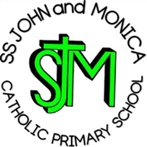

SS John and Monica Catholic Primary School
Prospectus
2018/2019

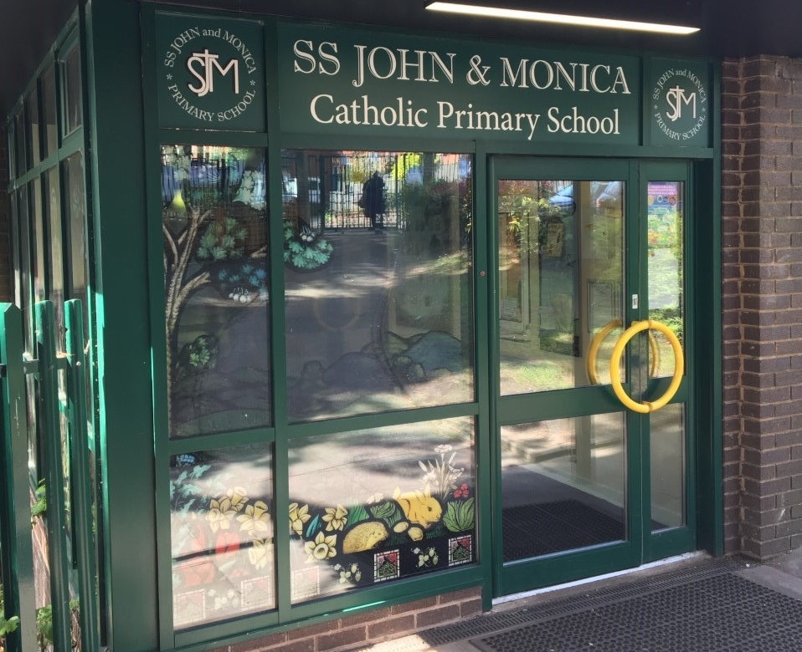

Across the school, teaching is effective and enables most pupils to make increasingly good progress’

Provision for pupils’ spiritual, moral, social and cultural development is extensive and a real strength of the school.

‘Behaviour of pupils is outstanding’

Ofsted June 2018

MISSION STATEMENT

“At SS John and Monica, we learn through the example of Jesus, to love, respect, understand and value each other.”



WELCOME

Dear Parent/Carer,

This prospectus is intended to give parent/carers with children at our school, or parents selecting a school for their children, a clear view of what SS John and Monica Catholic Primary School is all about. It contains information which we hope will be of value to existing and prospective parents or anyone else who is interested in the school.

As a Catholic school we have a special responsibility to deliver the National Curriculum, strengthened by the religious ethos of the school and our close links with the parish of St. John and Martin.

The Governors are justly proud of the school and its achievements (see page 29) and place great emphasis on the school's multi-cultural environment. I hope you find the prospectus interesting and if you have any questions please contact the Head Teacher, Acting Deputy Head, Acting Assistant Head Teacher or any of the Governors.

Mr P Foster

Chair of Governors

WELCOME

Dear Parents/Carers,
My name is Melanie Elliott and I am privileged to be the Head Teacher of SS John and Monica Catholic Primary School. SS John and Monica is a successful, vibrant and inclusive school which nurtures the ‘whole-child’, encouraging them to grow spiritually, academically, and socially.
Our mission is to strive to learn through the example of Jesus, to love, respect, understand and value each other. Our core purpose is to ensure that all children in our school have the opportunity and support to achieve their full potential. We recognise that it takes a community to raise a child and we are proud of the strong partnership we have with our parents, parish and community.
As Head Teacher my aim is to work with our whole school community to guide our children throughout their educational journey, helping them to be successful life-long learners and positive role models, who can contribute to society in the future.

Mrs M. Elliott

Head Teacher

GOVERNORS

Chair: Mr P Foster
(Foundation)

Vice-Chair: Mrs S Tibbits
(Foundation)

Head Teacher Governor: Mrs M Elliott

Foundation Governors: Rev D Innamorati (SCJ)
Mrs A Murphy
Mr P Foster
Mr K Bio
Mrs S Tibbits
Mrs L Shinde

Parent Governors: Miss A Phillips
Mrs Hirminder Ubhi

LA Governor Mr S Ladak
Staff Governor Mrs C Jena

Clerk to the Governors: Miss H White

SCHOOL STAFF

Head Teacher: Mrs M Elliott

Deputy Head Teacher
(Acting) Mrs C Jena

Assistant Head Teacher
(Acting) Mr A Ullah

Class Teachers Miss C Pratty (Reception Class)
Miss R Millar (Year 1)
Miss H Geoghegan (Year 2)
Miss G Hodgkinson (Year 3)
Mr M Hawker (Year 4)
Mrs S Gray/Mrs H Mackay (Year 5)
Mr A Ullah/Mrs C Jena (Year 6)

Teaching Assistants
Mrs T Ali-Shahid
Mrs L Hodges
Mrs C Morgan
Miss C McKeown
Miss L Hill
Office Staff Mrs T Broadhurst
(Headteacher’s PA & Senior Office Manager)
Mrs R Khan (Secretary-Part-time)
Mrs M Croke (Administrative Assistant – Part-time)

Cook Supervisor: Mrs K Wallace

Breakfast Club Supervisors: Mrs J Saunders & Mrs K Wallace

SS. John and Monica
Catholic Primary School
Our Core Values

- To develop a Christ-centred community in which the Catholic Faith is nurtured and where a knowledge of and respect for other world religions is fostered.
- To establish an environment and ethos (clearly understood values and attitudes) within which individual children may develop their own potential for the benefit of themselves and the rest of society.
- To enable children to acquire the basic skills of literacy and numeracy.
- To enlarge a child's knowledge, experience and imaginative understanding and thus enhance his/her awareness of moral values and capacity for enjoyment.
- To develop in children the ability to make reasoned judgements and choices based on the interpretation and evaluation of relevant information, e.g. to develop a critical and discriminating attitude towards the mass media.
- To help children to appreciate human achievements in art, music, science, technology and literature
- To deliver a high standard of education to all pupils guided by the school Mission Statement and in line with Local Authority and National Curriculum statements.

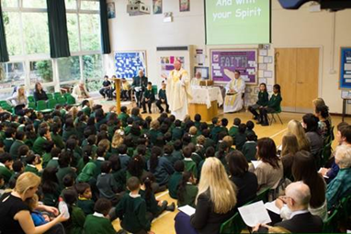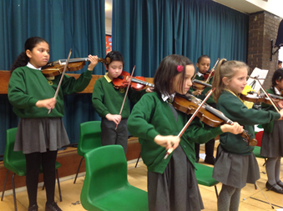

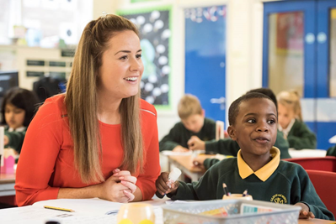

GENERAL AIMS OF THE SCHOOL

• To develop a Christ-centred community in which the Catholic Faith is
nurtured and where a knowledge of and respect for other world
religions is fostered.

• To establish an environment and ethos (clearly understood values and
attitudes) within which individual children may develop their own potential for the benefit of themselves and the rest of society.

• To enable children to acquire the basic skills of literacy, oracy and
numeracy.

• To enlarge a child's knowledge, experience and imaginative
understanding and thus enhance his/her awareness of moral values and capacity for enjoyment.

• To develop in children the ability to make reasoned judgements and
choices based on the interpretation and evaluation of relevant information, e.g. to develop a critical and discriminating attitude towards the mass media.

• To help children to appreciate human achievements in art, music,
science, technology and literature.

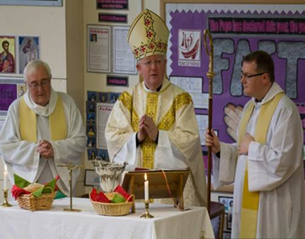

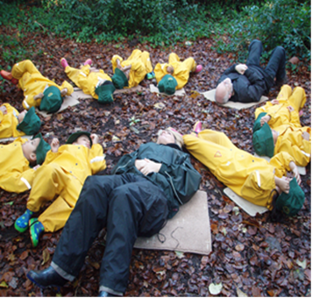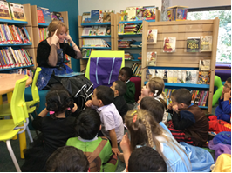

HISTORY OF THE SCHOOL

SS John and Monica Catholic Primary School is a voluntary aided school opened in September l980, following the amalgamation of the St. John's Infant and Ss. Monica's Junior Schools. The premises occupied at the present time were built in l970. The school serves the Parish of Ss. John and Martin and draws its children from the Balsall Heath/Moseley/Edgbaston area.

As a Catholic School, the basic religious ethos is to be found across the whole curriculum and not just within religious education lessons. The aim of the school is to encourage the Christian growth of the child. Parents are encouraged to attend the weekly school masses. Parents are also closely involved in the preparation of their children for the Sacraments of Reconciliation (Penance), First Holy Communion and Confirmation.

SS John and Monica Catholic Primary School recognises the need for children to be prepared for life in a multi-cultural society by fostering respect for diversity, and by seeking to counter racist and discriminatory attitudes.

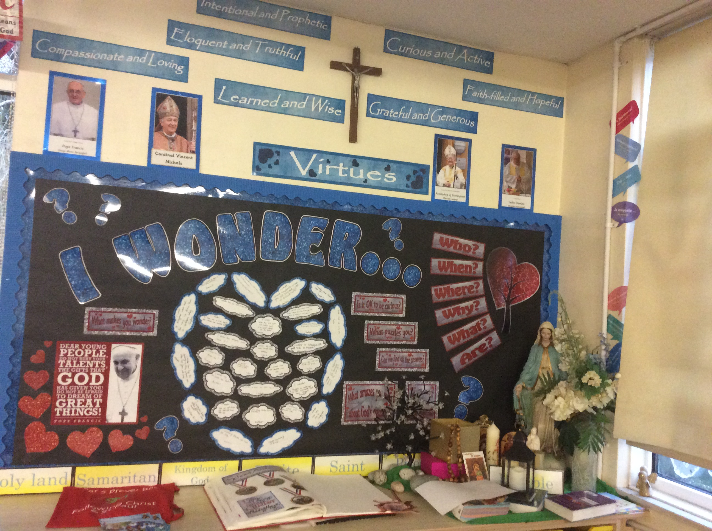

.

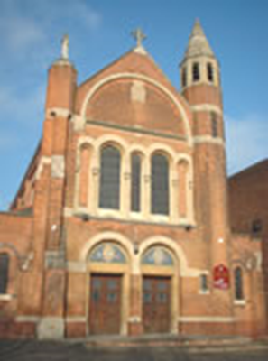

St John & Martin’s Church

Parish Church

SS. John and Martin Church
George St., Balsall Heath,
Birmingham
B12 9RG

Telephone: 0121 440 3025

Parish Priest: Fr. D. Innamorati

Email: info@stjohnandmartin.org.uk

Website: www.stjohnandmartin.org.uk
Mass Times:

Monday 9.30 a.m. in the Church
Tuesday 9.30 a.m. in St Martin De Porres School
Wednesday 9.30 a.m. in the Church
Thursday 9.a.m. in SS John & Monica School
Friday 9.30 a.m. in the Church
Saturday 10.00 a.m. in the Church
Sunday 10.00 a.m. in the Church

St John the Evangelist and St Monica are The Patron Saints of our School

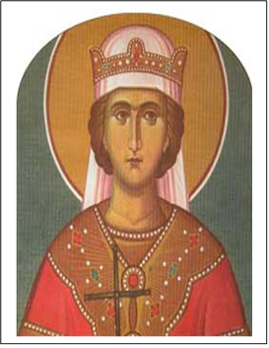

SCHOOL CHAPLAIN

Father Dominic is our Parish Priest and works closely with the school in many ways, celebrating mass, hearing confessions. He is concerned with the spiritual welfare of the children. We are very fortunate to have such generous support.

SAFEGUARDNG & CHILD PROTECTION

Our first priority is your child’s welfare and therefore there may be occasions when our concern about your child means that we have to consult other agencies even before we contact you. The Birmingham Safeguarding Children Board has laid down the procedures we follow. If you want to know more about this procedure, please speak to the Head Teacher. Following recent September 2016 legislation the school’s policy for Safeguarding and Child Protection has been updated and is available on the school website. If any parent has a concern about a child please speak to the Head Teacher, or another DSL. Alternatively phone Children’s Advice and Support Service (CASS) on
0121 303 1888.



PARENTS AND FAMILIES

The School is noted for its family atmosphere, fostered by experienced and dedicated staff.

We enjoy good relationships amongst ourselves and are equally supportive to our pupils and parents. The staff will try to be available for a chat when possible, at the end of the day.

When we welcome a child, we welcome a family.

Parents' Evenings are twice a year. The first meeting, which is usually held early in the autumn term, gives parents an opportunity to discuss how their child has settled in with their new teacher and discuss targets for the year. The second meeting, in the spring term allows parents to see their children's work and to discuss progress made during the year. We invite the child to the meeting, as it is their work, progress and behaviour, which are being discussed. A report on your child's progress will be sent home at the end of the summer term. Parents then have the opportunity to come in and discuss the report if they so wish.

However if you are ever worried about any aspect of school you should contact us immediately. If you wish to see your child's work or consult the teacher at other times, please contact the Secretary to make an appointment. This will ensure that the proper time may be given to deal with the matter. In the case of urgent matters, these will be dealt with at once.

Whilst we welcome the support of parents, recent child protection legislation insists that all adults who work with children have a DBS check (Criminal Records Bureau). Occasional support such as on school trips, sports day etc may be exempt from this.

During the course of the academic year we run many social and fundraising events, which would prove less successful without the parents' support.

Parents are warmly invited to School Mass which is held on Thursdays at 9.00 a.m. (except for the 1st Thursday of every new half term).

Parents of Reception children will be invited each year to join their child for lunch. This is an opportunity for parents to see how their child manages themselves at lunchtime and can be very reassuring.

Parents of Reception will also be invited to attend an Inspire Workshop at some point in the year. These prove to be an invaluable insight to parents about how their child is being taught and will help parents help their child at home with their learning:

FOREST SCHOOL at SS JOHN AND MONICA

In addition to our usual classroom activities, we offer children the chance to take part in Forest School learning sessions throughout the year. One of our teachers has a Forest School Leader qualifications, and sessions are conducted in small groups.

The school provides weatherproof clothing for the sessions, dungarees, jackets and wellies for the smaller children and rainproof jackets and trousers with wellies for the older children.

We conduct our Forest School sessions throughout the year and in all
weathers – rain or shine, though we do not take children out in instances of high winds, extremely heavy rain or electrical storms.

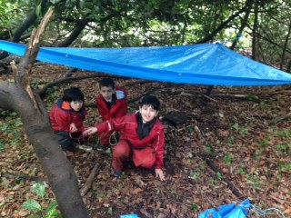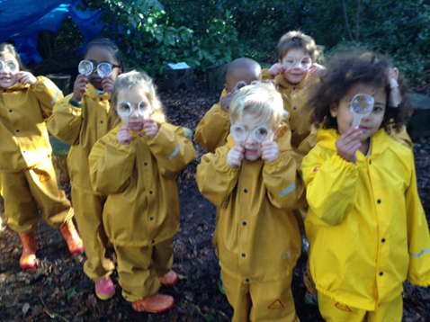

SPECIAL EDUCATIONAL NEEDS & DISABILITIES (SEND)

SS John & Monica’s recognises and values all children as individuals and as such all children are entitled to a quality education that recognises their individuality and responds to their personal, social, emotional and academic needs. We feel that within this recognition of individuality is the potential for children to have a range of academic and behavourial levels and our aim is to respond quickly and appropriately to their needs as far as resourcing will allow.

We recognise that some children will have a “Special Educational Need or Disability” (also referred to as SEND) at some stage of their school life. These needs will come in a range of type (e.g. Moderate Learning Difficulty, Autism), severity and duration and therefore the need for constant observation, assessment, target setting, liaison with parents and external agencies and review of all children is paramount to fulfilling our commitment to a quality education for all. As a result of this cycle of assessment and review we can ensure that all children are offered a curriculum which is broad and balanced, addresses their individual needs and has staff that are responsive to difficulties and ensure quick intervention where necessary.

At SS John & Monica’s we strive to bring school and home into closer and more effective communication in all aspects of their child’s life. We involve parents in all stages of the Special Educational Needs process and aim to provide a supportive network exchange of information and to help parents help their children. Changes in circumstances can impact the needs of the child and we encourage parents to contact school to discuss their children whenever this may be the case, likewise teachers will contact parents as soon as difficulties become apparent. The child is central to education and at all stages of planning and review we aim to make children involved in their goals, ensuring they are consulted whenever practicable and their viewpoint noted. Such records are good indicators of the less measurable success criteria such as improved self-image, confidence, and perception of ability and areas of interest. We aim to give children ownership of their learning and the opportunities to evaluate their achievements.

All schools are in the process of updating their policies and practise to have regard for the Governments SEND Code of Practise 0 – 25 which will become law from September 2014. The school SEND Information Report is available on the school website.

PASTORAL CARE

Our Christian approach to all children makes SS John and Monica School very special in the sense that all children, parents and staff belong to a family.

All staff are very caring from the first day a child comes into school and no pupil should ever feel isolated.

Our multi-cultural education policy ensures that we respect the different traditions and faiths of our non-Christian children.

PHYSICAL EDUCATION

- ALL children take part in all P.E., games, sports and swimming (in Key Stage 2 only)

- If a child is ill, a child may be excused by a doctor's note or in exceptional circumstances written request from a parent

- Please label all items of clothing, e.g. ties, P.E. kit, jumpers etc. with your child's name. Children must have full P.E. kit (see page 11 for details) in school at all times

- All children will need pumps for use in the hall.

One of the aims of the school is to encourage participation in a variety of physical activities. Children go for intensive swimming tuition in Years 3, 4, 5 and 6.

In KS/KS2 there have been opportunities to participate in PE lessons held by sports specialists and coaches. This has come about through the liaison of our PE/Sports co-ordinator with a network of primary and secondary school families whose aim is to facilitate the provision of extra PE in the form of after school clubs and tournaments. These opportunities vary throughout the course of the year and parents are informed of any such provision in the future as it affects certain age groups.

FAMILY LIFE EDUCATION

Pupils in Y5/Y6 follow the Diocesan guidance for the delivery of Family Life using the “All that I am guidance and “A journey in Love”. Pupils in other year groups are taught the developing elements of family life through their RE lessons PSHE Curriculum and Science Curriculum

HOMEWORK

Homework is set in Reception and consists of reading. In KS1 homework consists of reading, spelling and basic numeracy.

Children in KS2 will be asked to complete certain tasks at home during the course of the week. They will also be expected to know all their tables by the end of Year 4. Homework will increase in Years 5 & 6. There is a homework policy available

SCHOOL DISCIPLINE

The school follows the discipline policy of the Birmingham L.E.A. The co-operation and support of parents is considered to be essential in the maintenance of good order within the school. A parent may be sent for if the behaviour of a child is thought to be totally inappropriate.

BEHAVIOUR POLICY

We believe it is essential that SS John and Monica's School be first and foremost a place of justice and peace. This philosophy underpins every aspect of our school life, and is evident in our dealings with each other, the curriculum we present to our children and the ways in which we deliver that curriculum. We are not a Catholic school in name only. Our very ethos proclaims our Christianity, and our attitudes and dealings with everyone connected with school life reflects the teachings of Christ.

Our behaviour policy is aimed at helping every member of our school community to fulfil their potential. It intends to help create and maintain a happy, caring environment where people can work and play in safety. It aims to promote good effort and behaviour, building self-esteem and encouraging self-discipline. It should also provide a support for those children who find self-discipline more difficult to maintain.

A whole school approach to the management of pupil behaviour demands a team effort by all members of the staff, teaching and non-teaching staff alike, where staff are supported and supportive to each other. Adults and children alike must be aware of their individual and collective responsibility to the smooth and safe running of the school.

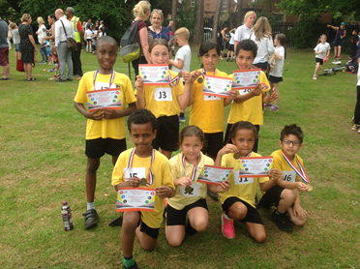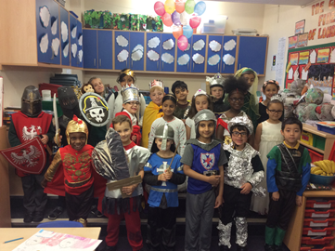

SCHOOL HOURS

It is essential that you get your children to school in good time.

Breakfast Club Available From:
8.00am daily

School Open from 8.45am

School Starts: 8.55am

Infant Lunch: 12.00 – 1.00pm
Junior Lunch: 12.15 – 1.15pm

School Day Ends: 3.15pm

There is a 15-minute interval during the morning session for both Reception/KS1 and KS2

Children should NOT arrive at school before 8.45am unless they are using the breakfast club, which opens at 8am. The school building opens at 8.45 am and pupils are invited to go straight to their classrooms at this time

At the breakfast club children take part in an exercise class for approximately 20 minutes after which they have their breakfast from a choice of wholemeal toast, cereal, yoghurt and fresh fruit. All of this for £2.00 per day!

Please ensure that your child is collected punctually at 3.15pm. If you are unexpectedly delayed, or if someone else is collecting your child, please inform the school beforehand.

SECURITY

- Electronic gates have been fitted to the entrance of the school. All parents visiting the school during the day will need to press the intercom button to gain access.

- All external doors will be kept shut and locked to the outside at all times.

- All visitors during the school day will have to sign the visitor’s book and wear a badge of identity. All visitors will be escorted by a member of staff. People on site without a badge or accompanying member of staff will be challenged.
- As the Reception Class, Year 1 and Year 2 have a separate external door; parents will collect them from that door.

- Years 3, 4, 5 & 6 will be dismissed from the Junior Playground at 3.15pm where parents will be able to meet them.

SCHOOL UNIFORM

Can be purchased at Clive Marks – Kings Heath High Street

The Governors require all pupils to wear the distinctive school uniform. This helps to create a feeling of belonging - children can take pride in being a part of SS. John and Monica's family when they wear it. It also has a practical side, in that, uniform clothes are made to last leaving the children's better clothes for home use. These are the Governors detailed requirements:

Winter Uniform | Summer Uniform
Grey skirt, pinafore/trousers | Green gingham dress
Green v neck sweater/cardigan | Grey Shorts
White shirt and school tie | Yellow polo shirt
White/black/grey socks/tights (no leggings) | Green v neck sweater/cardigan
Sensible black shoes (no slip-ons) | Sensible black shoes (no slip-ons)

Please refer to the photographs below:
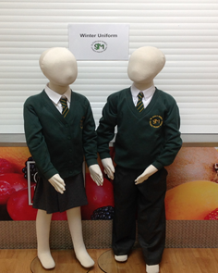
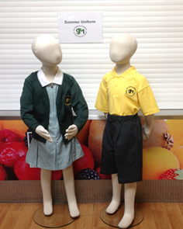

- For safety reasons No jewellery is allowed in school except for one stud earring in each ear.

- Please put your child’s name & year in each item of clothing to enable us to return lost property to you.

PLEASE NOTE: Please DO NOT allow children to bring toys, mobile phones or games to school - these may become lost or broken and the school can take no responsibility for their safety.
SCHOOL MEALS

Dinner money should be sent to the school each MONDAY MORNING in a clearly marked envelope, stating the child's name, class and amount of contents.

1 day lunch money = £2.30
2 days lunch money = £4.60
3 days lunch money = £6.90
4 days lunch money = £9.20
5 days lunch money = £11.50

This price is subject to change by order of the Local Authority.

• Applications/enquiries for free meals should be made to the School Office.
• Children may bring a packed lunch. Children bringing a packed lunch can choose to purchase pizza on Friday. Contact the office for details.
• Please note: liquids MAY NOT be sent in tins or glass containers.
• All containers should be secure to avoid damage to schoolbooks, P.E. equipment.
• We would prefer children to only swap from packed lunches to school dinners and vice-versa at the beginning of a half term.

DINNER MONEY

Dinner Money is recorded electronically and the following procedures need to be followed:

Dinner money must be paid weekly in advance using the School Money on line system. An e-mail is generated automatically as a receipt of payment. No cash is accepted in the office.

Please note that the school cannot allow debts to accrue. Repeated failure to pay your child’s dinner money may result in your child having to bring in packed lunch.

YOUR SUPPORT IS APPRECIATED.

ABSENCES

Children should attend school every day unless too poorly to come to school. Please ring the school office on 0121 464 5868 by 9.00am. You will receive a text from school asking you to contact us if we do not hear from you on the first day. In accordance with governmental policy (2013) holidays during term time will not be authorised by the Head Teacher. Pupils are required to be in school for the prescribed 190 days unless they are too ill to attend. The school’s detailed attendance policy is available on the school website.

Parents who insist on taking their children away during the school term will need to complete a Home School Contract and provide evidence of the return flight date. Failure to do this may result in your child’s name being removed from the school roll and their place being offered to a child on the waiting list.

The 2018/2019 school target for attendance is 97% for all pupils in Years Rec - 6. Pupils who attain the school target for attendance will be part of the whole school reward we arrange for the summer term. We hold a focus attendance week every month and children who attend for 100% of that week are entered into a prize draw.

ILLNESS OR ACCIDENT AT SCHOOL

In the event of a child needing to go home due to an illness or accident, the parents will be contacted. For this reason - it is essential that we are kept informed of any change of contact number/address including a minimum of 3 emergency contact numbers.

MEDICAL/DENTAL VISITS

The school must be informed in advance when a child will be attending a medical appointment. All non-emergency medical appointments should be made out of school hours to reduce lost learning time for your child. Please report to the School Office before collecting your child. The office will ask to see a copy of the appointment card/letter to confirm why the child is out of school (in accordance with our attendance procedures)

NO CHILD may leave the school premises during the day unless an adult accompanies them and they have secured permission from the Head Teacher.

MEDICINES

Wherever possible you must organise administering your child’s medication when they are not in school but if this is not possible because the doctor has prescribed 4 daily doses for example, we will do our best to accommodate you. If your child needs to take medication you can make arrangements to come in to school to administer the medication yourself or we can supervise your child taking their own medication. Parents must remember that staff are not required to give pupils routine medication but we will do what we can to support parents who would have difficulties managing this due to work or location. We follow the recent Government legislation regarding Managing Medicines in Schools (2014) and all subsequent updates.

In instances where the medication is for a life threatening condition, a named member of staff will be responsible for the required administration and record keeping.

Under no circumstances should you send your child in to school with medication in their bags. The school office will ask you to come into school and sign a document stating the names and doses of any medication your child needs to take. If your child can take the necessary medicine themselves we will supervise them taking it. The medicine should be delivered to the school office if it has to be on site during the school day and we will ensure it is stored correctly. It is the parents responsibility to provide only what is required and complete the paperwork correctly or we will be unable to give the medicines.

If your child has asthma and has a prescribed inhaler from your GP you should ensure that they have a spare one that can be kept in school. It should be clearly labelled with your child’s name and expiry date. If your child requires a spacer this must be provided by the family. Each class has an asthma box which will be accessible to your child at all times. It is a parent’s responsibility to check expiry dates. Only reliever inhalers are allowed in school, which are usually blue.

Pupils who require Epipens or Piriton (anti-histamine) must have them prescribed by their doctor. These must be labelled with the child’s name, date of birth and date of prescription.

SCHOOL BOOKS AND MUSICAL INSTRUMENTS

Children are encouraged to take books home. However loss or misuse or damage to books could result in that privilege being withdrawn as well as a charge being made for the replacement.

Year 4 pupils get the opportunity to learn a musical instrument, which they will be allowed to bring home. The instrument and music books are brought into school each week for the lesson. Pupils in Year 5 and 6 are offered the opportunity to continue playing their musical instrument if they show ability and interest.

COMMUNICATION

A fortnightly newsletter is electronically sent by e-mail each Friday to keep parents informed of the activities taking place in school. This newsletter and more information about the school can be found on the school website (www.stjonmon.bham.sch.uk) or you can join us on our Twitter page (@SSJohnMonicas). Important dates, such as holidays and trips, are included. We strive to ensure that class teachers are available to meet with parents to discuss pupils as required either informally in the playground or by appointment after school (through the school office).

EXTRA-CURRICULAR ACTIVITIES 2018/2019

We offer a range of extracurricular activities on a rolling programme across the year.

A charge of £3.50 per session is made for all internal clubs. External clubs are run by a private company who are fully DBS checked.

PARKING

Please remember to be courteous and safe in your parking. Only park where there are no zig-zag lines and do not block the driveways of the neighbouring houses. Lots of our families live within walking distance of the school. Why not park a good walking distance from the school to give your child the chance for exercise in the fresh air and save on congestion around the school.

HOLIDAY DATES 2018/2019

Autumn Term

Open Close

Monday 3rd September Friday 29th October
Monday 5th November Friday 21st December

Spring Term 2019

Open Close

Monday 7th January Friday 15th February
Monday 24th February Friday 12th April

Summer Term

Open Close

Monday 29th April Friday 24th May
Monday 3rd June Friday 19th July

N.B. There are 5 other Teacher Training Days that will be fixed later in the year.

SECONDARY TRANSFER

Last year children from SS John and Monica Catholic Primary School transferred to the following Secondary Schools:

SECONDARY SCHOOLS

Bishop Challoner R.C. School | 1 | Queensbridge School | 6
Selly Park Girls’ School | 4 | St Thomas Aquinas | 2
K.E Camphill Girls | 1 | Kings Heath Boys | 3
Moseley School | 2 | Sutton Coldfield Grammar Girls | 1
K.E Handsworth Boys | 1 | Moseley School | 3
Holy Trinity Catholic School | 1 | Ninestiles School | 1
Nishkam High School | 1 | Ark St Albans | 1
City Academy | 1 | Harborne Academy | 1

CHARGING AND REMISSIONS

A copy of the Governors policy is available from the school office

COMPLAINTS

A copy of the Governors policy is available from the school office and on the school website.

TELEPHONE NUMBERS

Birmingham Education Department General Enquiries 303 2590

Ss. John and Monica School Tel: 464 5868

Fax No: 464 5046
E-Mail: head@stjonmon.bham.sch.uk
Website: www.ssjonmon.bham.sch.uk
Twitter: @SSJohnMonicas

SS. John and Martin Presbytery 440 3025

