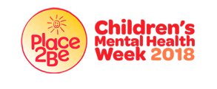
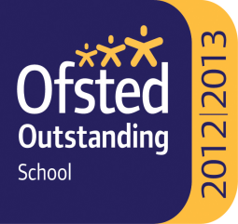

Ss. John & Monica’s Catholic Primary School – Bulletin 11
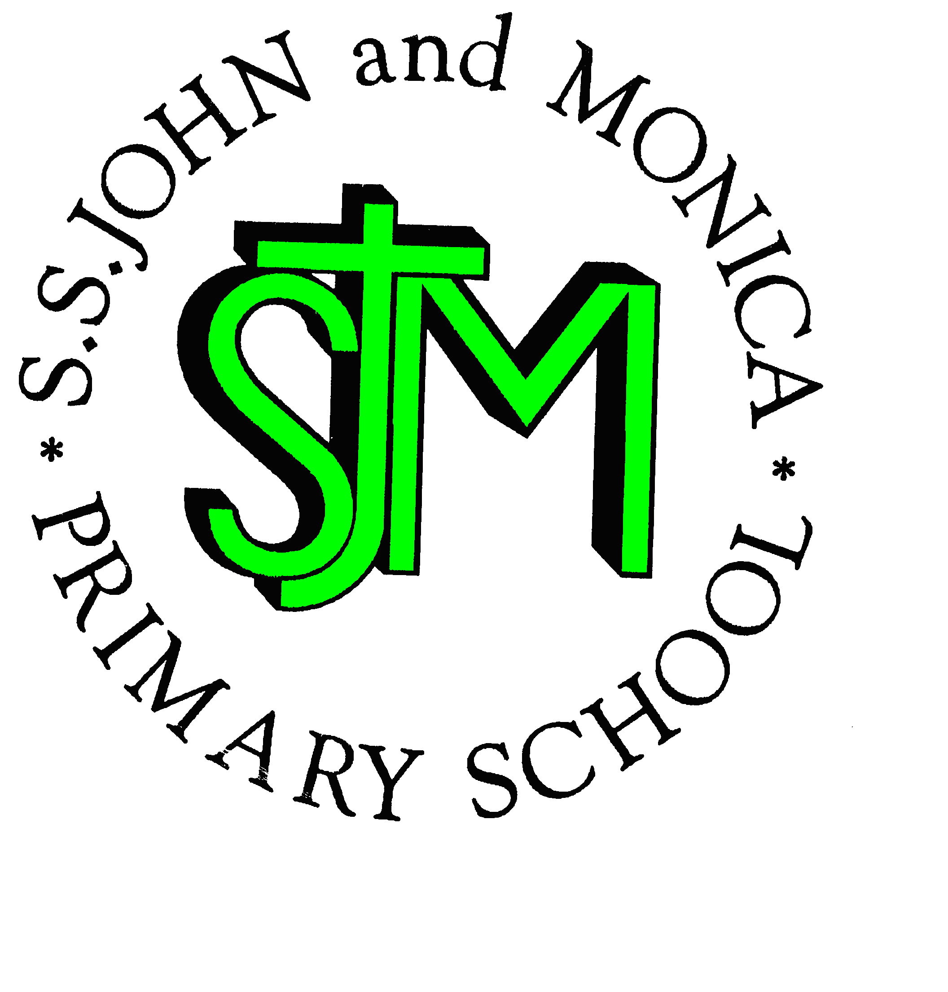

Telephone: 0121 464 5868

Fax: 0121 464 5046
Email: enquiry@stjonmon.bham.sch.uk
Website: www.stjonmon.bham.sch.uk
Twitter: @SSJohnMonicas

Friday 2nd February 2018
Term | Start | Half Term | Reopens | Term Ends
Spring 2018 |  | Monday 19th February | Monday 26th February | Thursday 29th March
Summer 2018 | Monday 16th April- School Closed Training  Tuesday 17th April - School Open for Pupils | Monday 28th May | Monday 4th June | Friday 20th July

Class Mass

The next school Masses will be celebrated on the following dates and all friends and parishioners are most welcome to attend:

Thursday 8th February at 9:15am prepared by Year 4: The theme of the Mass is St. Agatha (5th)

Thursday 15th February at 9:15am prepared by Year 1: The theme of the Mass is Our Lady of Lourdes (11th)

.
First Holy Communion Inscription Mass
The children making their First Holy Communion this year are required to attend the Inscription Mass on Sunday 4th February. Please make sure children arrive at the Church no later than 9:45am. It is expected that a parent will also attend this Mass and all subsequent Masses with their child. All those in our school community, who wish to support these children, are very welcome to join them at the 10:00am Mass at St John and Martin’s Church.

HSA Meeting
The aim of the Home School Association (HSA) is to develop strong links between home and school and to raise much needed funds for school resources. If you would like to be involved, a meeting will be held on Thursday 8th February 2018, at 2:30pm, in the Forest School. All parents are invited and welcome.

Y6 Mosque Visit
BINGO! 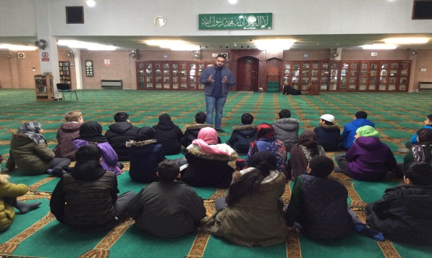
The children in Y6, as part of their multi-cultural learning, visited Birmingham Central Mosque this week. During the visit, the children were given a guided tour of the mosque building accompanied by a faith guide, and took part in a question and answer session. The visit was extremely successful and the children are looking forward to writing about their experience.

The children thoroughly enjoyed an afternoon of numbers at the Bingo. It was great fun for all and even better for the lucky winners! Thank you for all your donations, a total of £102.13 was raised towards school fund.

Life Bus
Children enjoyed meeting Harold in the Educational Life Bus last week! Each class were encouraged to take a positive attitude towards their health, and identified how they can make informed decisions about healthy choices in their lives.

Being ‘School Ready’
We ask that parents help to ensure all children come to school equipped and ready to learn. This includes making sure that children are getting enough sleep, appropriate to their age, and have had breakfast before the start of school. Children then will be energised and ready to learn. The following NHS website gives you guidelines as to how many hours sleep per night children should have depending on their age http://www.nhs.uk/Livewell/Childrenssleep/Pages/howmuchsleep.aspx

Enabling Enterprise
Well done to some of our Y5 pupils who visited Aston University to develop their enterprise skills. Please visit Twitter: @SSJohnMonicas for photos of the day!

Y6 Bell Heath Residential: Wednesday 6th – Friday 8th June 2018
A scheduled payment total of £75 for the Y6 Residential trip to Bell Heath is now overdue. If you are having difficulties meeting these payment deadlines, please contact the office ASAP to arrange a meeting. The total payment deadline on the schedule is April 1st but monies can be paid in full online is preferred.

Mathletics and Reading Eggs
Your child will have their Mathletics and Reading Eggs passwords in their reading diaries. Please encourage and support your child to access these wonderful sites at home to do set and additional homework, and challenges linked to maths and reading. Please let your child’s class teacher know if you do not have access to the internet at home as an opportunity during the school week will be allocated to enable them to access these resources. Homework must be completed on a weekly basis.

Punctuality
Punctuality is extremely important and is monitored very closely. Indeed, vital learning can be lost if children are late on a regular basis. The school doors open at 8.45am and school starts at 8.55am. At this time children need to be in their classrooms, ready to learn. If you have an issues regarding punctuality or attendance please book an appointment to speak to Mrs Mason, our Attendance Officer.

Attendance for the last 2 weeks:Week 22nd-26th Jan Well done to Year 6 98.6 %. Week 29th-2nd Feb Well done to Year 1 97.7 %
Class | Reception | Year 1 | Year 2 |  | Year 3 | Year 4 | Year 5 |  | Year 6
% Attendance | 93.6% | 98% | 95.9% |  | 93.3% | 95% | 86.7% |  | 96%
Lates | 8 | 5 | 9 |  | 22 | 6 | 9 |  | 8
Whole School Attendance so far this year |  |  |  | 95.7% |  | School Target |  | 97%
The next attendance focus week is the week beginning Monday 5th february. Make sure you are in school every day to be in with a change of winning an attendance prize!

The Golden Book – The following children have been chosen for exceptional work and behaviour. Well done to everyone!
Reception: Miss Pratty, Mrs Shepherd & Mrs Nadeem | Ivo Short & Khadija Marouf
Year 1: Miss Millar & Mrs Hirji | Hafsah Ali & Yunis Hussain
Year 2: Mrs Larkin & Mrs Hodges | Oliver Stanley & Khio Brown-Campbell
Year 3: Miss Hodgkinson & Miss Hill | Whole Class & Kinza Lone-Ebrahim
Year 4: Mr Hawker & Miss Morgan | Suhaan Ayoub & Sami Ahmed
Year 5: Mr Ullah & Mrs Ali | George Jones &Elijah Nyassa
Year 6: Miss Gee, Mrs Gray & Miss McKeown | Merlina Mullings & Sara Hussain
Mrs Jena: Assistant Head Teacher | Natasha Kauser - Year 6 & Zain Gulzar – Year 6
Mrs Elliott: Head Teacher | Ismail Hussain – Year 4 & Davinder Kitaure – Year 3

Dates for your Diary
Date | Event | Time
Monday 5th February | Children’s Mental Health Week: A week to celebrate uniqueness and being ourselves
Thursday 8th February | Birmingham Royal Ballet Visit to Y1 | 1:30pm
Monday 12th February | National Poetry Week
Wednesday 14th February | Ash Wednesday Service: Beginning of Lent

Children’s Mental Health Week

This is a time to reflect on how we can encourage children to reflect upon their uniqueness. When we have a positive view of ourselves it can help us to cope with life’s challenges, and how recognising the qualities of others can enable us to connect with those around us – vital for own and others’ wellbeing.

‘I alone cannot change the world, but I can cast a stone across the waters to create many

ripples.’ - Mother Teresa.

Mrs M. Elliott

Head Teacher
Mrs E Walker – Executive Headteacher

Mrs E Walker- Executive Headteacher

