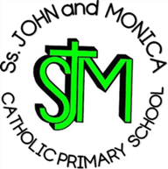
Ss. John & Monica’s Catholic Primary School – Bulletin 12

Telephone: 0121 464 5868

Fax: 0121 464 5046
Email: enquiry@stjonmon.bham.sch.uk
Website: www.stjonmon.bham.sch.uk
Twitter: @SSJohnMonicas

Friday 16th February 2018
Term | Start | Half Term | Reopens | Term Ends
Spring 2018 |  | Monday 19th February | Monday 26th February | Thursday 29th March
Summer 2018 | INSET DAY -Monday 16th April  School Closed Training  Tuesday 17th April - School Open for Pupils | Monday 28th May | Monday 4th June | Friday 20th July

INSET
Advance Notice of our next Training Day 2018 - School will be closed to pupils on Monday 16thApril for Staff Training; School will be open to pupils from 8:45am on Tuesday 17th April.

Class Mass

The next school Masses will be celebrated on the following dates and all friends and parishioners are most welcome to attend:

Thursday 8th March at 9:15am prepared by Year 5: The theme of the Mass is the 3rd Sunday of Lent

Thursday 15th March at 9:15am prepared by Year 2:The theme of the Mass is the 4th Sunday of Lent

.
Visiting Head Teacher
Last week, we were delighted to welcome a visiting Head Teacher form Eskilstuna, Sweden. The week was spent shadowing Mrs. Elliott, meeting and observing staff and pupils, and visiting our wonderful city! It was a delight to hear how very impressed she was with the behaviour and outcomes of our pupils, all of whom were a credit to our school community throughout the week.

Staff
We would like to say a temporary farewell to Mrs. Austin, who will be working at our neighbouring school St. Martin De Porres, after Half-Term. Mrs. Austin will be greatly missed and we wish her every success in this exciting opportunity. We look forward to welcoming her back after the Summer Term.

We are delighted to welcome Mr. Hannon, the new Building Services Manager, to Ss. John & Monica’s after the half-term holiday. Mr Hannon and his family will reside in the School House and I am sure will be made to feel very welcome by the whole school community.

Punctuality
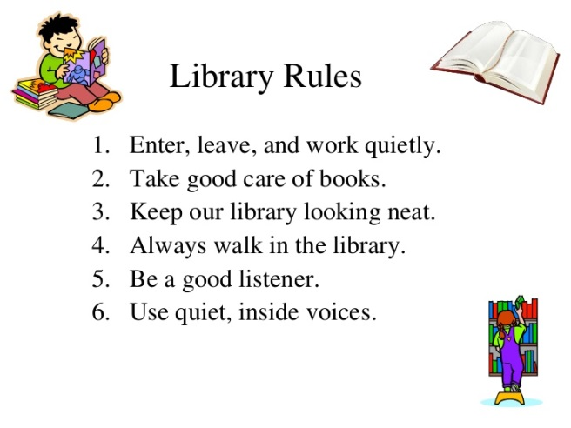
It has been noticed that more children are regularly arriving late for school. Punctuality is extremely important and vital learning can be lost if children are late on a regular basis. The school doors open at 8.45 am and pupils are expected to be in school by 8.55am; Children need to be in their classrooms at this time ready to learn. If you are experiencing difficulties getting your children to school on time, please book an appointment to speak to Mrs Mason, our Attendance Officer.

BINGO!
School Library
The school library is open every Tuesday and Thursday from 3:15-4pm. Pupils and parents from both Key Stages are welcome on either evening. This is a wonderful opportunity for parents to support us in promoting a love of reading and we would like to encourage you to visit whenever you are able.

Y6 Bell Heath Residential: Wednesday 6th – Friday 8th June,
monies can be paid in full online is preferred.

Parents Evening
Parents Evening will take place on the evening of Thursday 22nd March. After half-term, all parents will receive
a text message regarding booking appointments online. If you do not have access to a computer, you will be able
to ring the school office where we can manually book an appointment for you.

NSPCC Visit
The NSPCC will be visiting our school on 5th and 19th March to work with the children; keeping our children safe on-line is of paramount importance when they are accessing the Internet, social networks, apps and games. The following links are ones we strongly advise you to visit if you wish to find out more about on-line safety:
http://www.saferinternet.org.uk/

https://www.nspcc.org.uk/

http://www.internetmatters.org/

Attendance for the last 2 weeks: Week 5th-9th Feb Well done to Year 1 97.9%. Week 12th-16th Feb Well done to Year 6 98.5%

Well done to the following children who achieved 100% attendance during our ‘Attendance Focus Week’: Rec Fleur & Ivo,
Y1 Zofia & Aleksander, Y2 Ali & Amanda, Y3 Ariana & Adam, Y4 Sara & Raul, Y5 Rocco & Ria, Y6 Dalisha & Dayyan.
Class | Reception | Year 1 | Year 2 |  | Year 3 | Year 4 | Year 5 |  | Year 6
% Attendance | 91.4% | 97% | 96.8% |  | 96.8% | 94.5% | 95.5% |  | 92.8%
Lates | 5 | 7 | 8 |  | 13 | 6 | 6 |  | 10
Whole School Attendance so far this year |  |  |  | 95.6% |  | School Target |  | 97%

The Golden Book – The following children have been chosen for exceptional work and behaviour. Well done to everyone!
Reception: Miss Pratty, Mrs Shepherd & Mrs Nadeem | Serena Santra & Elijah Johnson
Year 1: Miss Millar & Mrs Hirji | Bailey Bowen & Ranell Dhillon
Year 2: Mrs Larkin & Mrs Hodges | Mariam Mohamed & Bavleen Kaur
Year 3: Miss Hodgkinson & Miss Hill | Ryan Trojan & Foz Hussain
Year 4: Mr Hawker & Miss Morgan | All of Year 4 & Spencer Gilbert
Year 5: Mr Ullah & Mrs Ali | Caoimhe Tetsowo & Alzubir Aldubai
Year 6: Miss Gee, Mrs Gray & Miss McKeown | Pen Xian Liang & Adrhys Aslam
Mrs Jena: Assistant Head Teacher | Talha Aldubai & Juwariyah Mubarek – Year 6
Mrs Elliott: Head Teacher | All of Year 5 & Vincent Kokolaki-Hall - Reception

Dates for your Diary
Date | Event | Time
Monday 26^{h} February | School re-opens for Spring Term 2 | 8:45am
Thursday 1st March | World Book Day 2018
Monday 5th March | Global Learning Project Week
Wednesday 7th March | Y4 Library Visit to Balsall Heath Library
Friday 9th March | Science ‘WOW’ Experiment Day

Lent

We have now begun the season of Lent, which began on Ash Wednesday, starting the 40 day period of fasting to represent the 40 days Jesus spent fasting in the wilderness. We ask that the children endeavour to keep their Lenten promises and consider ways in which they can live out Jesus’ teachings during the Season of Lent.

Wishing you all a restful holiday

Mrs. M. Elliott

Head Teacher
Mrs E Walker – Executive Head teacher

Mrs E Walker- Executive Head teacher

