SS John & Monica Catholic Primary School
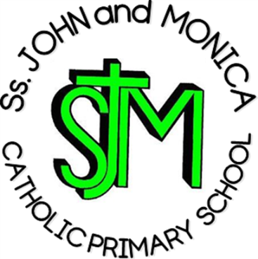
Headteacher:
M. Elliott (B.Ed. Hons., NPQH)

Chantry Road
Moseley
Birmingham B13 8DW

Telephone: 0121 464 5868
Fax: 0121 464 5046
Email: enquiry@stjonmon.bham.sch.uk
Website: www.stjonmon.bham.sch.uk
Twitter: @SSJohnMonicas @2014Erasmus

Curriculum Information Letter – Summer 2019

Dear Parents,

We would like to welcome you back to school. We hope that you and your family have had an enjoyable holiday. In this letter you will find an overview of the work that your child will be completing during this term. Please find opportunities to support your child’s learning by doing additional research on any new topics.

RE | We will complete the remaining units from our scheme ‘Learning and Growing as the People of God’ this term: Easter; Pentecost; Jesus Teaches Us How to Pray; Sharing in the Life of Christ; and Special Roles and Responsibilities.
English | Reading: This term, Year 4 are continuing to read ‘The Lion, the Witch and the Wardrobe’ by C. S. Lewis. In addition, the children will cover a range of texts (both fiction and non-fiction), so please do encourage your child to explore different genres in order to complement their learning.  Writing: The children will be taught a range of writing genres (fiction and non-fiction) based on our key texts. Genres include: fiction with an element of fantasy; chronological reports; information texts; recounts; persuasive writing; and nonsense poetry.  Grammar, Punctuation and Spelling:  Grammar, punctuation and spelling will be taught from the Programme of Study for Year 4.
Maths | In Year 4, we are learning all about the following:  Number and Place Value; Addition & Subtraction; Multiplication & Division; Fractions (including Decimals); Measurement; Geometry (Properties of Shape, Position and Direction) and Statistics.  Please support your child with learning their times tables regularly as they will be tested weekly and will aid much of their mathematical learning.
Science | This term, we are learning all about animals including humans and living things and their habitats.
Computing | T Throughout this term, we will be focusing on coding and debugging a series of algorithms.
PE | PE will occur every Wednesday in the afternoon. Please ensure your child has the correct PE kit (t-shirt, shorts &/or tracksuit, pumps for indoor PE and trainers for outdoor PE). Your child’s kit should be kept in school and washed every half-term. A letter should be provided if your child is unable to participate in PE for a medical reason.
Music | Guitar lessons will take place in school every Monday afternoon.
French | T Children will develop their understanding of spoken French and will work towards using spoken language with confidence and accuracy.
History/Geography | This term, the children will be exploring the Indus Valley Civilization.

Homework | Reading: Each child will read on a daily basis in either whole class sessions, small groups or individually. Reading records will be checked daily to ensure home reading is taking place. Please read with your child every day and sign their reading diary. Reading books must be brought to school every day.  Spelling: Weekly spelling lists will be given out on Fridays and tested the following Friday. Please learn these words daily using the ‘Look, Say, Cover, Write, Check’ method.  Times Tables: All times tables up to 12 should be learnt by the end of Year 4. Further to this, children should know the inverse operations for each multiplication calculation.  Other: Maths and English homework will be given out on a Friday and should be completed and returned the following Friday, unless requested for a specific date.
Attendance and Punctuality | This year we have a school target of 97% for pupils in Rec– 6. It is very important that your child attends school every day that they are fit and well. Pupils with an attendance score of less than 90% are regarded by the Government as having Persistent Absence and parents will be invited into school. All pupils who achieve an attendance of 97% or more will be invited to the Annual Attendance Reward Visit for excellent attendance!
Other Information | Mass: Thursday 9th May  Swimming: Monday 3rd June (2 weeks)  Sports Day: Wednesday 19th June  Birmingham Conservation Park Trip: Friday 21st June

If you have any questions please speak to me informally in the playground at the end of the day or make an appointment through the school office.

Yours sincerely,

Mr Hawker and Mrs Ali

