SS John & Monica Catholic Primary School
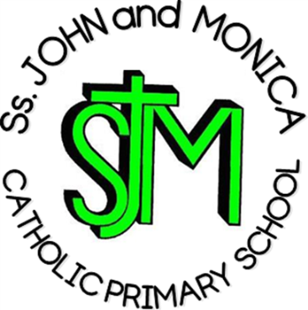
Headteacher:
M.Elliott (B.Ed. Hons.)
Chantry Road
Moseley
Birmingham B13 8DW

Telephone: 0121 464 5868
Fax: 0121 464 5046
Email: enquiry@stjonmon.bham.sch.uk
Website: www.stjonmon.bham.sch.uk
Twitter: @SSJohnMonicas @2014Erasmus

Curriculum Information Letter Y5 – Summer 2019

Dear Parents,

We would like to welcome you back to school. We hope that you and your family have had an enjoyable holiday. In this letter, you will find an overview of the work that your child will be completing during this term. Please find opportunities to support your child’s learning by doing additional research on new topics.

RE | The children will be studying the units: Easter, Pentecost, the work of the Apostles and Marriage and Holy Orders. The first Year 5 Mass be on the 23rd May, please come and celebrate with us.
English | Reading: This term we will continue to read a selection of different texts. We will also be continuing with the book Holes during reading sessions. Each child will read on a daily basis in either whole class sessions, small groups or individually. Reading records will be checked daily. Please spend a minimum of 10 minutes a day listening to your child read and sign their records accordingly.  Writing: Our writing this term focus on developing our editing and drafting skills within a range of different writing types. There will be a particular focus on narrative and story telling together with persuasive techniques.  Grammar/Punctuation/Spelling: Spelling will be expected to continue to learn their spellings weekly ready for testing. I ask that a parent or guardian support their child with the writing of their sentences and test them when they have learnt their spellings. In class, we will continue to focus on punctuation and grammar through our writing lessons.
Maths | Topics that will be covered include transformations, measure, ratio, reasoning problems, decimals and percentages as well as revision of all previous topics.  Children should be learning or revising their multiplication facts and corresponding division facts at home to 12x12.  Please test your children as much as possible on these facts as they will be tested weekly.
Science | Summer 1 – Animals including humans.  Summer 2 – Properties of Materials.
Computing | Online safety/coding
PE | Our P.E session will now take place every Friday, so please ensure your child has the correct kit. A letter should be provided if your child is unable to participate in P.E for a medical reason. This term we are lucky to be working with a tennis coach.
Geography | Extreme Earth –physical features such as tsunamis, volcanoes and earthquakes.
History | Vikings and Anglo Saxons

Homework | Reading: Daily  Spelling: Daily – Spelling test Thursday  X/÷ Facts: Daily  Other: Mathletics and Reading Eggs homework will be available throughout the week. Please ensure that your child logs in to complete. If there are any issues please do not hesitate to speak to a member of the Year 5 team. Homework books for Maths and English will be regularly sent home also.
Attendance and Punctuality | This year we have a school target of 97% for pupils in Year 1 – 6. It is very important that your child attends school every day that they are fit and well. Pupils with attendance of less than 90% are regarded by the Government as having Persistent Absence and pupils with attendance in danger of falling to this level will be invited into school. All pupils who achieve attendance of 97%+ will be invited to the Annual Attendance Reward Visit for excellent attendance! Good Luck
Other Information | Class Mass Thursday 26th May  Sports Day – 19th June  Details of our class trip will follow in due course.

If you have any questions please speak to me at the end of the day or make an appointment with me through the school office.

Yours sincerely

Mrs Gray and Mrs Goddard

