Learning Project WEEK 5- Environments
Age Range: EYFS
Weekly Maths Tasks (Aim to do 1 per day) | Weekly Reading Tasks (Aim to do 1 per day)
- Watch a Numberblocks clip each day at: BBC or CBeebies. Use this guide here to give you ideas on what to do with your children whilst watching an episode.  - Working on Numbots - your child will have an individual login to access this.  - Play the Numberblocks add and subtract quiz.  - Practise counting up to 20. This can be done through playing hide and seek, singing number songs, chanting, board games etc.  - Write out the digits 0 - 9.  - Practise recognising amounts up to five or up to ten by playing these games. This can be done by reading a dice when playing board games, playing with cards, identifying how many food items on the plate etc.  - Listen to a number song from the CBeebies website. After listening to them, watch again and sing along if you can. Talk about the maths you can see in the video clip. | - Read a variety of books at home. Favourites can be repeated. Hearing the patterns of language in a story will support your child’s language development.  - Reception age children: Children to read to parents daily. Visit Oxford Owl for free eBooks that link to your child’s book band. You can create a free account.  Complete the linked Play activities for each book.  - With your child, look in magazines, newspapers and books for the tricky words they are currently learning. They could use a highlighter to highlight in magazines and newspapers.
Weekly Phonics Tasks (Aim to do 1 per day) | Weekly Writing Tasks (Aim to do 1 per day)
- Sing Nursery Rhymes and songs together. Add in actions and change the words. Can children think of different rhyming words to add in? Repeat old favourites and learn new rhymes. You can find an A-Z of Nursery Rhymes here.  - Daily phonics - Practice the sounds your child is working on and blend words. This can be oral blending (e.g. spoken out loud c-a-t) or written if appropriate. Interactive games.  - Sing the song, ‘Incy, Wincy Spider’ and add in the rain sounds using your rainmaker (from the learning project below). | - Practice name writing. Can they write their first name? Middle name? Surname?  - Practice forming the letters of the alphabet. Follow your school’s script.  - Ask your child to write out the tricky words they are working on at the moment on pieces of paper and turn them into a pairs game.  - Take your child for a litter pick around your front and back garden. Create a poster to remind people to put rubbish in the bin.
Learning Project - to be done throughout the week
The project this week aims to provide opportunities for your child to learn more about the environment. Learning may focus on changes to different environments, the impact of humans on environments, climate change etc .

- Create a daily weather chart-
  - Record using pictures and written labels (where appropriate). How has the weather changed over the week?
  - If it is raining, leave a container outside to collect the rain e.g. a water bottle with the funnel cut off. Draw a line or make a mark to show where the rain came up to. Repeat overnight or the next day and compare your results.

- Recycling/ Exploring Materials-
  - Provide your child with a selection of packaging to sort into groups to recycle. Can they identify plastic, paper, card, metal.

- Create your own rain cloud-
  - Use a plastic container with a lid (e.g. a water bottle) and make small holes on one side. You could stick on cotton wool to decorate. Fill the container with water and watch as the water drips out.

- Weather sounds (Rainmakers)
  - Provide your child with either a plastic container, bottle or other junk modelling item. Pour in a spoon or two of rice or lentils and secure with a bottle lid or sellotape. Decorate with stickers, glitter and sequins if you have them available. Have fun exploring making rain sounds.

- Ice-
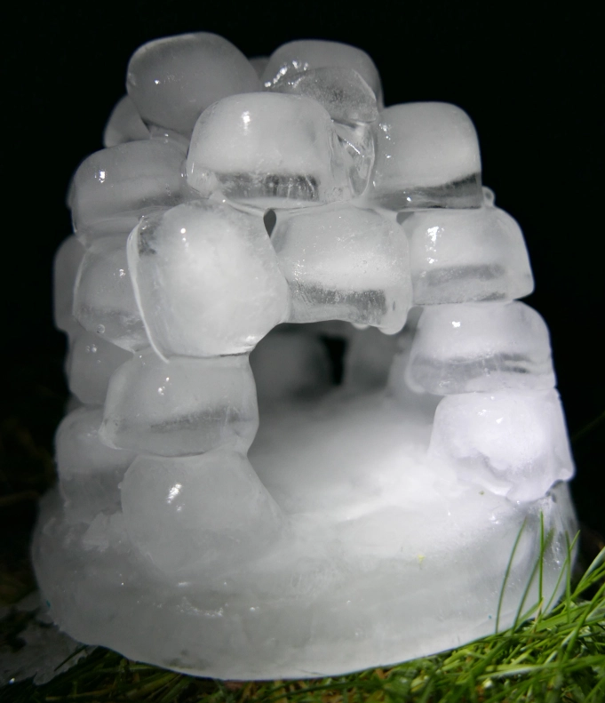
  - Watch ‘Frozen- In Summer’. Discuss with your child what they think will happen to Olaf when it gets warm. Support your child to fill up ice cube trays or plastic containers, if ice cube trays are not available, and freeze. Once frozen, take them out and explore how quickly they melt: in your hands, in the fridge, on the windowsill and when blown with the hairdryer.
  - Search on Google Maps for the UK. Discuss with your child the colour of the land and sea. Scroll up to look at the Arctic. Discuss why the land looks different in the Arctic, because the land is covered in snow and ice. Discuss the differences in temperature in the UK and the Arctic. Look at a picture of an igloo on google.
Fill an ice cube tray with water and when frozen take out and support your child to create their own igloo out of the ice cubes.

Additional learning resources parents may wish to engage with
Classroom Secrets Learning Packs - These packs are split into different year groups and include activities linked to reading, writing, maths and practical ideas you can do around the home.
Twinkl - to access these resources click on the link and sign up using your own email address and creating your own password. Use the offer code UKTWINKLHELPS.
Headteacherchat - This is a blog that has links to various learning platforms. Lots of these are free to access.
#TheLearningProjects

