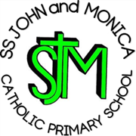
SS John & Monica Catholic Primary School
Head Teacher:
M.Elliott (B.Ed. Hons, NPQH)
Chantry Road
Moseley
Birmingham B13 8DW
Telephone: 0121 464 5868
Fax: 0121 464 5046
Email: enquiry@stjonmon.bham.sch.uk
Website: www.stjonmon.bham.sch.uk
Twitter: @SSJohnMonicas

Monday 9th March

Hindu Temple visit

Dear Parents/Guardians

I am pleased to inform you that on Tuesday 17th March year 5 will be visiting the Shri Venkateswara Balaji Temple in Oldbury as part of our RE work exploring other faiths.

We will leave at 0915 on the coach and will return in time for lunchtime.

Yours sincerely

J Catling
Year 5 teacher

