Ss. John and Monica Catholic Primary School
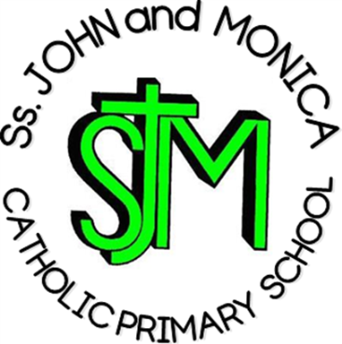
Headteacher:
M.Elliott (B.Ed. Hons) NPQH
Chantry Road
Moseley
Birmingham B13 8DW

Telephone: 0121 464 5868
Fax: 0121 464 5046
Email: enquiry@stjonmon.bham.sch.uk
Website: www.stjonmon.bham.sch.uk
Twitter: @SSJohnMonicas @2014Erasmus

EYFS Curriculum Information Letter – Autumn 2018

Dear Parents

We would like to welcome you to SS John & Monica’s. We hope that you and your family have had an enjoyable holiday and that you enjoy your time at our school. In this letter you will find an overview of the work that your child will be completing during this term. Please find opportunities to support your child’s learning by doing additional research on new topics.

RE | We will be covering the following topic:  - Creation  - People who care for us  - Advent  - Christmas  - Our class saint, Mother Teresa  - School prayers
English | Reading: The children will be become increasingly confident in the following areas of reading:  - Linking sounds to letters and hearing and saying the initial sounds in words.  - Sounding out simple words  - Talking about what has been read.  Please bring your child’s book bag to school every day.  Writing: The children will be practising letter formation and writing the letter to represent the sounds they hear. They will begin to write some simple words including their full name.
Maths | The children will be covering the following topics:  - Recognising, ordering, writing and counting with numbers to 10 and beyond  - Making numbers to 10 (early number bond work)  - 2D shapes  - Pattern  - Time – days of the week and months of the year  - More and less
Communication & Language | The children will be learning to listen attentively in a range of situations, respond to instructions involving a two part sequence and join in with small group discussions. The children will be encouraged to retell simple past events and use more complex sentences to share thoughts and ideas.
Personal, Emotional and Social Development | The children will be encouraged to initiate conversations, speak about their needs, wants, interests and opinions and ask questions.  Children will also be learning that their own actions affect other people.
Computing | Children will have access to the school’s ICT suite and I Pads. The children will become familiar with the use of computers and will have access to a number of programs including Reading Eggs and Mathletics to support their development in reading and maths.
PE | Our focus this term will be balance, flexibility and body management. Through our PE sessions children will learn to negotiate space, adjusting speed and direction. The children will explore balance and their ability to control movements.
The World | Our Autumn topic will be ‘All About Me’ and will involve work related to:  - Families  - Homes  - Hobbies  - Growing and changing  - Likes and dislikes  We will also celebrate significant days in our academic calendar e.g. Eid, Diwali, Bonfire Night.

Homework | Reading: Children will have reading books sent home, these will be changed when your child is familiar with the story and confident to discuss the characters and events. Please bring your child’s book bag to school on a daily basis and sign their reading diaries.
Attendance and Punctuality | This year we have a school target of 97% for pupils in Year R – 6. It is very important that your child attends school every day that they are fit and well. Pupils with attendance of less than 90% are regarded by the Government as having Persistent Absence and pupils with attendance in danger of falling to this level will be invited into school.
Other Information | 26TH September – 2.30pm EYFS/KS1 Parents Reading Meeting  Week Beginning 22nd October – EYFS Parents Evening  4th December – 9.10am Reception Inspire Workshop

If you have any questions please speak to me informally at the end of the day or make an appointment through the school office.

Yours sincerely
Miss Pratty

