SS John & Monica Catholic Primary School
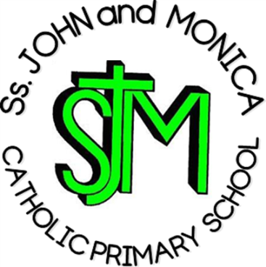
Headteacher:
M. Elliott (B.Ed. Hons., NPQH)

Chantry Road
Moseley
Birmingham B13 8DW

Telephone: 0121 464 5868
Fax: 0121 464 5046
Email: enquiry@stjonmon.bham.sch.uk
Website: www.stjonmon.bham.sch.uk
Twitter: @SSJohnMonicas @2014Erasmus
EYFS Curriculum Information Letter – Summer 2019

Dear Parents

Welcome back to school. We hope that you and your family have had an enjoyable Easter Holiday. In this letter you will find an overview of the work that your child will be completing during this term. Please find opportunities to support your child’s learning by doing additional research on new topics.
RE | We will be covering the following topic:  - Easter  - Pentecost  - People Who Help Us  - Prayer  The children will also be learning to join in with some important prayers including the Hail Mary and Our Father.
English | Reading: The children will be become increasingly confident in the following areas of reading:  - Phase 4 words of Letters and Sounds  - Building a bank of irregular sight words  - Demonstrating an understanding of what they have read through asking and answering ‘how’ and ‘why’ questions.  - Attempting to read words of more than 1 syllable.  - Describing the main events in stories they have read.  Please bring your child’s book bag to school every day.  Writing: Our work this term will be focused on some exciting core texts including ‘The Very Hungry Caterpillar’ by Eric Carle and ‘The Smartest Giant in Town’ by Julia Donaldson. The children will be encouraged to work independently when writing labels, captions and sentences which can be read by themselves and others.
Maths | The children will be covering the following topics:  - Addition of 2 single digits by counting on  - Subtraction with 2 single digits by counting back  - Solving problems involving halving and sharing  - Space and Measure (Weight, position, distance and money)  - Counting and grouping in 2’s, 5’s and 10’s.
Communication & Language | The children will be encouraged to respond to stories and instructions they hear with relevant comments, questions or actions. The children will have opportunity to answer ‘how’ and ‘why’ questions about their own experiences. They will also be developing their own narratives and explanations by connecting ideas or events.
Personal, Emotional and Social Development | This term the children will be encouraged to work in groups taking account of one another’s ideas about how to organise their activity. The children will be expected to be able to talk about how they and others show feelings. Reception pupils will also have the opportunity to lead a school mass and perform a class assembly later in the term.
Computing | The children will work with the following resources this term:  - Ipads  - Computer suite – children will have an opportunity to use a range of software.  - Programmable toys including BeeBots
PE | This term we will be concentrating on Physical Literacy which focuses on speed, agility and travel. We will also be refining our ball skills. Parents must ensure their child has a full PE kit in school. The kit will remain in school until half term.
The World | We will be covering the following topics:  - Moseley – The local environment  - Minibeasts – life cycles, changes and habitats  - Plants – growing, comparing and observing  - Seasons – Summer

Homework | Reading: Children will continue to have reading books sent home, these will be changed when your child is familiar with the story and confident to discuss the characters and events.  Keywords/Spellings: Your child will be tested on their set of words on a weekly basis and new words will be given when appropriate.  Maths: All children have their math’s challenge booklets in book bags. Please sign and date as the activities are completed.
Attendance and Punctuality | This year we have a school target of 97% for all pupils. It is very important that your child attends school every day that they are fit and well. Pupils with attendance of less than 90% are regarded by the Government as having Persistent Absence and pupils with attendance in danger of falling to this level will be invited into school.
Important Dates | Friday 28th June - Reception Assembly  Thursday 11th July – Reception Mass  Friday 12th July - Summer Trip to Hatton Country Park

If you have any questions please speak to me informally at the end of the day or make an appointment through the school office.

Yours sincerely
Mrs Riches

