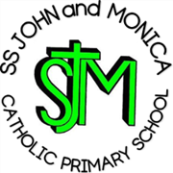
SS John & Monica Catholic Primary School
Head Teacher:
M. Elliott (B.Ed. Hons, NPQH)
Chantry Road
Moseley
Birmingham B13 8DW
Telephone: 0121 464 5868
Fax: 0121 464 5046
Email: enquiry@stjonmon.bham.sch.uk
Website: www.stjonmon.bham.sch.uk
Twitter: @SSJohnMonicas

18.11.19
Dear Parents/Carers,
I am writing to you with regards to the escalating concerns and issues around children being dropped off and collected from school. The safety of our children, parents and local residents is being compromised by the selfish and inconsiderate driving and parking behaviour of a small minority.
Recently, I have been inundated with complaints from local residents about parents parking illegally in front of their driveways, obstructing them from leaving their premises. This obstruction this is a criminal offence and residents have informed me that they have cctv and photos and that they will be reporting these to the police.
I have also had complaints from parents and witnessed myself, parents driving dangerously outside the school gates. This includes reversing onto pavements where children are walking, driving fast, double parking, pulling up on the zig-zag lines and letting children cross the road unattended.
The above issues have been bought to the attention of SS John and Monica School Governing Body who are discussing the matter further. As a school, we have contacted the local police who will be monitoring the situation, along with Parking Enforcement Officers.
We ask you to think carefully when driving and parking outside our school and make sensible decisions that protect the safety of all our children and families.
Thank you for your co-operation in this matter.

Yours sincerely,
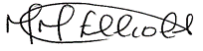

Mrs. M. Elliott

