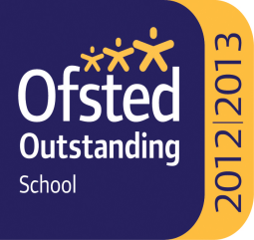

Ss. John & Monica’s Catholic Primary School – Bulletin 13
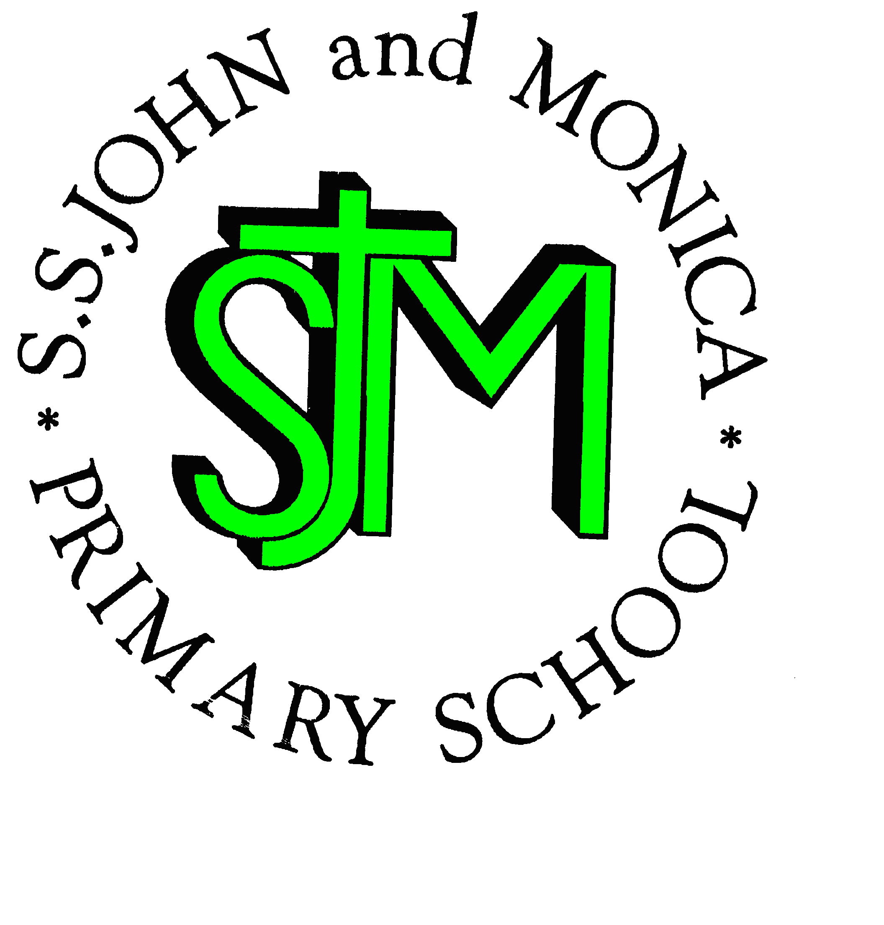

Telephone: 0121 464 5868

Fax: 0121 464 5046
Email: enquiry@stjonmon.bham.sch.uk
Website: www.stjonmon.bham.sch.uk
Twitter: @SSJohnMonicas

Friday 9th March 2018
Term | Start | Half Term | Reopens | Term Ends
Spring 2018 |  |  |  | Thursday 29th March - 2pm Finish
Summer 2018 | Tuesday 17th April | Monday 28th May | Monday 4th June | Friday 20th July - 2pm Finish

INSET
Advance Notice of our next Training Day 2018 - School will be closed to pupils on Monday 16thApril for Staff Training: School will be open to pupils from 8:45am on Tuesday 17th April.

Class Mass

The next school Masses will be celebrated on the following dates and all friends and parishioners are most welcome to attend:

Thursday 15th March at 9:15am prepared by Year 2: The theme of the Mass is the 4rd Sunday of Lent

Thursday 22nd March at 9:15am prepared by Year 6: The theme of the Mass is the 5th Sunday of Lent

.
World Book Day
World Book Day was a huge success, congratulations to everyone. There were so many wonderful activities taking place throughout the day and the children’s costumes were spectacular! A very special thank you to our visiting author Bibi Taylor, who worked with each class on creating and developing characters, the children had great fun whilst also finding out how the dream of being an author can be achieved. Thank you again for your support in making the day the success it was!
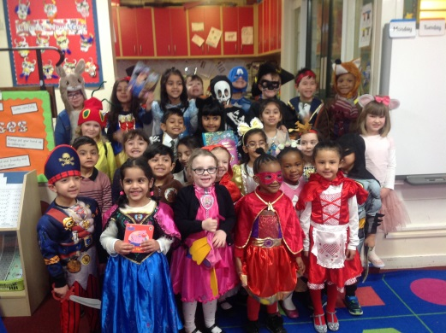
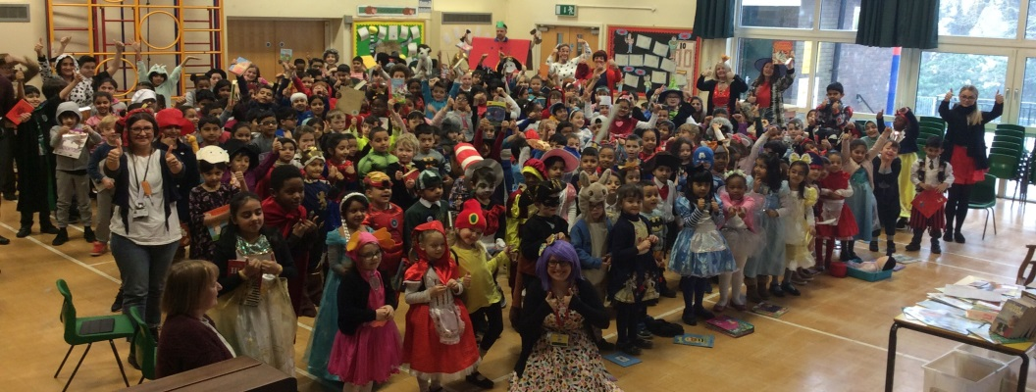

History Workshops
Year 4 and Year 5 were delighted to welcome the legendary teacher, Jonathan Davies, from King Edwards School this week. The two classes participated in two very exciting history workshops; These included ‘Building the impossible!’ for Y5, in which simple technology and ideas were discovered to find out just how clever and organised the Ancient Egyptians were in building pyramids with their bare hands. Y4 spent ‘A day in the museum’, in which they discovered the world of the Tudors through their belongings. Pupils arranged and analysed a wide range of artefacts and drew some conclusions, comparing the lives of the Tudors to their own. What a blast from the past!

Science ‘WOW’ Experiment Day
The children have enjoyed visiting different classes and teachers today, to learn all about the world around us through a variety of scientific experiments. It was wonderful to see the children’s curious minds at work! Below is a link that you may wish to use for those curious minds at home: https://www.howweelearn.com/43-science-experiments-to-blow-your-kids-mind/
Global Learning Week
This week, the Global Learning focus has been all about values. Classes have explored our British Values and learnt about the relationship with the international community, how other countries view us and how other countries are different compared to us. This has helped pupils to consider the place of Britain within international and global contexts.

School Drop Off & Collection
We would like to politely remind parents that pupils should be accompanied into school in the morning, and collected from their class teachers at the end of the school day. There has been an increase in the number of parents who do not collect their children directly from member of staff but rather stand at the gate entrance waiting for their children at the end of the school day. Again, a reminder that learning begins at 8:55am and the school day finishes at 3:15pm.

Parents Evening
- Parents Evening will take place on the evening of Thursday 22nd March; Parents will have received a text message regarding booking appointments online. If you do not have access to a computer, please ring the school office where we can manually book an appointment for you.
- Parents will be asked to complete an online questionnaire and complete a multi-consent form during this evening so please allow time for this to be carried out. We thank you kindly for your support.
- School Uniform will also be on display for parents; Please ensure your child’s uniform is in line with school policy.
- The Book Fair will be held in the school hall during Parents Evening

NSPCC Visit
The NSPCC visited our school this week to work with the children; keeping our children safe on-line is of paramount importance when they are accessing the Internet, social networks, apps and games. The following links are ones we strongly advise you to visit if you wish to find out more about on-line safety: http://www.saferinternet.org.uk/ https://www.nspcc.org.uk/
http://www.internetmatters.org/

Attendance for the last 2 weeks: Week 26th Feb-1st March - Well done toYear 4 with 99%. Week 5th-9th March - Well done to Reception Class with 99%.
We will be monitoring attendance and punctuality closely to ensure that no one slips into the persistent absence category, which is below 90% attendance.
Class | Reception | Year 1 | Year 2 |  | Year 3 | Year 4 | Year 5 |  | Year 6
% Attendance | 97% | 98% | 98.6% |  | 97.4% | 98.8% | 89.7% |  | 91%
Lates | 6 | 4 | 3 |  | 7 | 6 | 7 |  | 8
Whole School Attendance so far this year |  |  |  | 95.6% |  | School Target |  | 97%

The Golden Book – The following children have been chosen for exceptional work and behaviour. Well done to everyone!
Reception: Miss Pratty, Mrs Shepherd & Mrs Nadeem | Areeba Siddique & Muhammad Ibrahim
Year 1: Miss Millar & Mrs Hirji | Miya Nsoh & Pavandeep Jandu
Year 2: Mrs Larkin & Mrs Hodges | Talisha Michelle & Subhaan Rabbani
Year 3: Miss Hodgkinson & Miss Hill | Amith Krishna & Raffaele Conaty
Year 4: Mr Hawker & Miss Morgan | Ellah Baomer & Subhan Hussain
Year 5: Mr Ullah & Mrs Ali | Zaraib Nasir & Rocco Farrar
Year 6: Miss Gee, Mrs Gray & Miss McKeown | Haider Razaq & Jamel Gordon
Mrs Jena: Assistant Head Teacher | Aiza Siddique - Y4 & Adam Abdul-Galeel - Y2
Mrs Elliott: Head Teacher | Kai Walwyn – Y2 & Alana Vaughan – Y6

Dates for your Diary
Date | Event | Time
Friday 16th March 2018 | Year 1 Assembly | 9.15am
Wk. Beg: Mon 26th March | Lenten Fundraising for CAFOD and Father Hudson
Tuesday 27th March 2018 | Passover Meal - SS John and Martin’s Church | 7.00pm
Wednesday 28th March 2018 | Penitential Service - SS John and Martin’s Church | 7.00pm
Thursday 29th March 2018 | Easter Bonnet or Easter Garden Parade & Competition
Thursday 29th March 2018 | Maundy Thursday Evening Mass of the Last Supper - SS John and Martin’s Church | 8:00pm
Friday 30th March 2018 | Good Friday Celebration of the Lord’s Passion - SS John and Martin’s Church | 3:00pm
Tuesday 17th April 2018 | School re-opens for Summer Term 1 | 8:45am

Holy Week

As we continue to reflect during the season of Lent, we ask that the children endeavour to keep their Lenten promises and consider ways in which they can live out Jesus’ teachings during this important. Holy Week begins on Palm Sunday, which is on Sunday 25th March this year. This is the time when we particularly remember the last week of Jesus's life and reflect upon the strength of our own commitment to our faith.

Mrs. M. Elliott

Head Teacher
Mrs E Walker – Executive Headteacher

Mrs E Walker- Executive Headteacher

