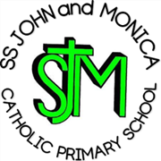
SS John & Monica’s Catholic Primary School – Bulletin 6

Telephone: 0121 464 5868

Fax: 0121 464 5046
Email: enquiry@stjonmon.bham.sch.uk
Website: www.stjonmon.bham.sch.uk
Twitter: @SSJohnMonicas

Friday 30th November 2018
Term | Start | Half Term | Reopens | Term Ends
Autumn 2018 |  |  |  | Fri 21st Dec - 2pm Finish
Spring 2019 | Mon 7th Jan Staff Training-School Opens Tues 8th Dec | Mon 18th Feb | Mon 25th Feb | Thurs 11th April – 3.15pm Finish  Training Day Friday 12th April
Summer 2019 | Mon 29th Apr | Mon 27th May | Mon 3rd June | Fri 19th Jul – 2pm Finish

Class Masses

The next school Mass will be celebrated on Thurs 6st Dec – Year 2 (Immaculate Conception of the Blessed Virgin Mary) and 13th Dec– Year 5 (St John Cross, priest and Doctor) at 9.00am. Parents, friends and parishioners are most welcome to attend.

Section 48 Religious Education Inspection
We would like to say a very big thank you to all our children during the Section 48 RE Inspection last week. The inspectors observed lessons in every class, a whole school assembly lead by Mrs Elliott and a whole school Mass lead by Year 4. A special thank you Year 4 pupils and Mr Hawker for preparing a beautifully reflective Mass. They scrutinised RE books, spoke to parents, pupils and staff and looked a range of school documentation. The full report is being finalised and, we have been told, will be with us by the end of the term. All families will receive a full copy of the final report. Initial feedback to the senior leaders and Governing Body is a very positive one. I am in no doubt that our school community will be very pleased with the report.

Christmas Fundraising - Monday 17th- Friday 21st December

During this week, all of the classes will be holding events to allow them to raise money for CAFOD (Catholic International Development Charity) and other local and national charities. Each class will be aiming to raise as much money as possible. Children should bring money into school on Monday 17th December and can enter all events: Please ensure money is placed in a sealed envelope labelled with your child’s name and class and pass to the Class Teacher. Thank you
YEAR GROUP | EVENT | COST | CHOSEN CHARITY
REC | Can enter all events | See Below | Spilt between below charities
Y1 | Collecting childrens clothes, donations from families to be sent to Africa | Clothes Donation | African Children Empowerment
Y2 | Movie Afternoon (Years 1 & 2) | £1 per child | Crisis Birmingham Homeless Charity
Y3 | Colouring Competition – winner announced Friday 21st December | 50p | Age UK
Y4 | Christmas Card Competition | 50p | Mind – Mental Health Charity
Y5 | Cake Sale | 50p | Acorns Children’s Hospice
Y6 | Fun Fair | £1 | Dementia UK

Christmas Theatre Trip

Rec & KS1 will be walking to the Midlands Arts Centre, as we did last year, to watch the Christmas Production ‘Rudolf’ on Friday 7th December , children to be collected at the normal time - 3.15pm, thank you.

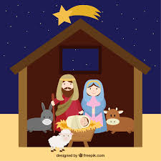
Christmas Performances

We would like to invite all parents to attend this year’s Christmas performances on the following dates:
- KS1 Nativity: Thurs 18th Dec at 9:30am (Doors open at 9.00am)
- KS2 Carol Concert: Wednesday 19th Dec at 2:00pm (Doors open at 1:30pm)

Raffle tickets, tea/coffee/mince pies/cake will be available on the day (£1.00). Programmes will also be are available on the day (donation of 50p). All proceeds to go to school fund.

SS John and Martin’s Parish Church and Christmas Fair
This year’s Parish Christmas Fair will take place in the Parish Hall of St John & St Martin’s Church, George Street, Balsall Heath on Saturday 8th December (12.00 – 2.00pm). We would like to ask our families to bake cakes that can be sold at the Parish Fair, in order to raise money for the Parish. Cakes can have a Christmassy theme (or not!) and teachers will judge the best cakes on Friday 7th December. All entrants will receive a small treat and there will be larger prizes for the winning cakes. We are also hoping that as many of our KS2 children attend to showcase their ‘Wake Up, Shake Up’ dance Skills Put the date in your diary, as it would be wonderful to see as many families as possible supporting this event.

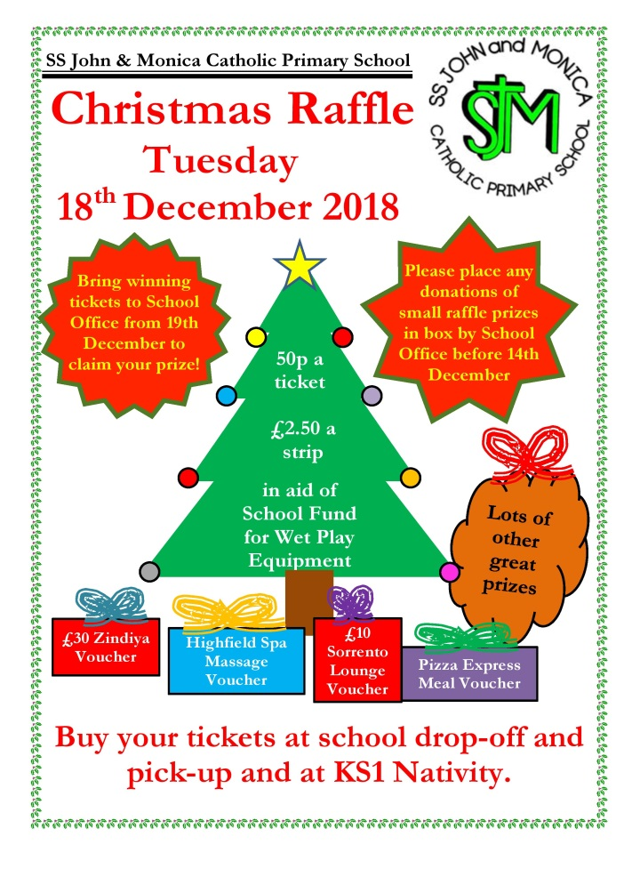
Raffle
Many thanks to our parents, Mrs Sakar (Serena’s mum) and Mrs Chakravorty (Chitrani’s mum) who have kindly organised this year’s parent’s raffle. Tickets will be available all day on 18th Dec (before school, during KS1 Nativity and at the end of the school day for all KS2 parents). There are some fantastic prizes on offer to win. If you would like to donate a prize for the raffle, please pass it on through the school office. Winners will be notified via phone call/text or email once the Raffle is drawn later that day.Thank you for your continued support to our school.

Dinner Money
Can you please ensure that school dinner money payments are up-to-date. Any dinner money arrears over £20 will result in parents being requested to send in packed lunches until the arrears have been paid. Please go to:
https://eduspot.co.uk/product/schoolmoney/

Christmas Parties
Each class will be holding a Christmas Party on Thursday 20th December. Children and staff are also invited to wear Christmas Jumpers on this day for £1.00 (proceeds to go to school fund). Children may also wear their own clothes. Children will be advised by their class teachers as to what food/drink they are required to bring in for the afternoon party.

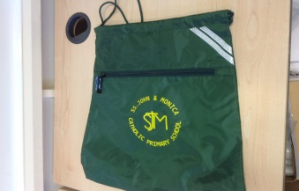
PE Bags
It has been noticed that some children are bringing their PE kits in rucksacks not PE bags. This means that there is little room for coats to be hung on pegs as well, often resulting in them falling onto the floor. This is a trip hazard and one we wish to avoid. Please ensure that your child brings their kit in a PE type Bag (either a school bought one or other). School bags are available at the school office priced £4.20. Thank you for your co-operation.

Guitar Performance
There will be a performance from our Year 4 and elective guitarists on Monday 10th December at 2.30pm. All parents/carers are welcome.

PARKING
A note from the Governors of SS John and Monica School - to remind parents to park legally and considerately outside school. There are still parents parking on yellow zigzags and it is unacceptable that parents are parking in front of the gates or neighbours driveways. We thank you for your cooperation in this matter.

Play Area
During the dark winter months the under 5’s Reception play area in front of the school will be closed at 3.30pm. The area can get particularly slippy during wet weather and for health and safety reasons it is not safe for small children to play when the light is fading.
Staffing
We are pleased to announce that we have employed a new Building Site Manager who commences his position next Monday 3rd Dec. Mr Ledger is moving from a large Secondary school, where he has worked for the past 17 years. We welcome him to the Ss John and Monica’s family and wish him well in his position.

Important Notice
When we return after the Christmas break, we are changing the arrangements for children coming into school. Reception children will continue to enter through the main gates and through the side entrance to their class as usual. To avoid the congestion we are experiencing in the morning in the school office, Years 1 to 6 will be asked to come through the main gates and make their way through the KS2 playground and enter into school through the back door. We are happy for the parents of our younger Year 2& 3 children (or any other year band if necessary) to accompany their children to the back door. There will be staff at the back door to pass on any messages, just as you were able to do when children came through the front door. Thank you for your co-operation in this matter.

Attendance
Well done to everyone who is working hard to keep up their fantastic attendance and strive to reach our end of year attendance target! It is wonderful to see that we are now slightly above our target of 97%. Let’s see if we can maintain this until the end of the term!

Attendance for the last 2 weeks: Week : 19th – 23rd Nov - Well done to Year 4 – 99.6%
Week: 26th – 30th Nov - Well done to Year 4 – 98.1%

Class | Reception | Year 1 | Year 2 |  | Year 3 | Year 4 | Year 5 |  | Year 6
% Attendance | 93.8% | 98% | 95% |  | 98% | 98.7% | 97% |  | 95.6%
Lates | 2 | 5 | 1 |  | 3 | 11 | 7 |  | 5
Whole School Attendance so far this year |  |  |  | 97.7% |  | School Target |  | 97%

The Golden Book – The following children have been chosen for exceptional work and behaviour. Well done to everyone!
Reception: Miss Pratty & Miss Morgan | Arthur & Melissa
Year 1: Miss Millar & Miss McKeown | Fleur, Klareece & Michaela
Year 2: Miss Geoghegan & Mrs Hodges | Imarni & Caleb
Year 3: Miss Hodgkinson & Mrs Ali | Lucas, Chloe & Whole Class
Year 4: Mr Hawker & Mrs Ali | Whole Class & Raffaele
Year 5: Mrs Gray & Mrs Mackay | Ismail & Sami
Year 6: Mr Ullah & Miss Hill | Sulaymaan & Dyntai
Mrs Jena: Deputy Head Teacher | Amera & Yusuf – Year 6
Mrs Elliott: Head Teacher | Ali K – Year 2 & Elena - Reception

Other Dates for your Diary
Date | Event | Time
Wk. Beg 3rd Dec- 7th Dec | SEND Reviews | pm
Tues 4th Dec | Reception Inspire Workshop – A representative for each child to attend | 9.15am
Fri 7th Dec | Year 3/Year 4 – Music workshop and performance St Chads | 9.00-2.30pm
Thurs 13th Dec | Christmas Dinner Day | 12.00-1.15pm
Fri 14th Dec | Dan Callow Advent Retreat Day – Whole School | All Day
Thurs 20th Dec | Y6 Mass – All parents/Carers welcome | 9.00am
Fri 21st Dec | School Closes for the Christmas Break | 2.00pm

NB: Please note school closes for the Christmas break on Friday 21st December 2018 at 2.00pm.

School re-opens on Tuesday 8th January 2019. (Staff Training on 7th January).

As we approach the Christian Season of Advent, let us prepare our hearts and minds for the coming of our Lord.

Mrs M. Elliott – Head Teacher

Christ the King
23rd November

