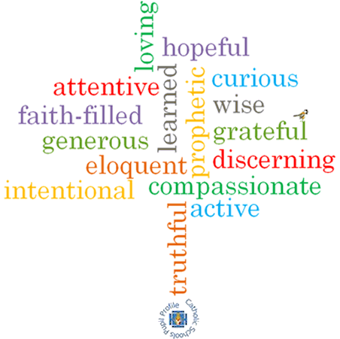
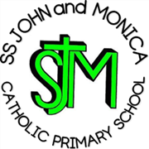
SS John & Monica’s Catholic Primary School – Bulletin 4

Telephone: 0121 464 5868

Fax: 0121 464 5046
Email: enquiry@stjonmon.bham.sch.uk
Website: www.stjonmon.bham.sch.uk
Twitter: @SSJohnMonicas

Friday 26th October 2018
Term | Start | Half Term | Reopens | Term Ends
Autumn 2018 |  | Mon 29th Oct | Mon 5th Nov –Training Day School Opens  Tues 6th Nov | Fri 21st Dec - 2pm Finish
Spring 2019 | Mon 7th Jan 2019 | Mon 18th Feb | Mon 25th Feb | Thurs 11th Apr – 3.15pm Finish  Training Day Friday 12th April
Summer 2019 | Mon 29th Apr | Mon 27th May | Mon 3rd June | Fri 19th Jul – 2pm Finish

Class Masses

The next school Mass will be celebrated on Thursday 15th Nov – Year 1 (November the Month of the Holy Souls) at 9.00am and Wed 21st Nov– Year 4 (St Cecilia) at 9.00am. Please note the change of date for the Year 4 Mass. Parents, friends and parishioners are most welcome to attend.

School Fund/Fund Raising
- We are most grateful to all parents who have made a donation to our school fund.To date we have raised £560. If you have not already done so and wish to make a donation, please send donations in an envelope to the school office.
- Thank for your generosity towards our charity CAFOD ‘Brighten Up Day’. The total raised was £194.96 - well done everyone! As a Catholic school we recognise the importance of raising money for those less fortunate than ourselves. Indeed, last year as a result of our Advent and Lenten charity fund raising efforts, we raised a total of £1573.25.

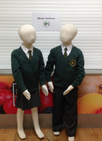
Winter Uniform/P.E Bags
A reminder that after half term all pupils should return to school in their winter uniform. This is a white shirt (not polo shirt) and tie, bottle green jumper/cardigan and grey skirt/trousers. Tights and socks should either be white, grey or black. Sensible shoes not boots or trainers should be worn. Thank you for your co-operation.

National anti-bullying Week 12th-16th November
Our PSHE Topic across the school this half term is ‘Say no to bullying’. There will be an Anti-bullying assembly on Monday 12th Nov and children across all year bands will explore various age appropriate topics around this theme. If you wish to read our Anti-bullying policy, please visit our school website using the following link:

http://www.stjonmon.bham.sch.uk/

Reception Parents/Carers Lunch

We are inviting all Reception parents/carers into school on Thursday 15th November at 11.50 for school lunch. This is a wonderful opportunity to share time with your child and sample some of the healthy food on offer. If you wish to share a meal/dessert with your child the cost will be £3.45 (payable via School Money). Alternatively you may just wish to come and be with your child for this special occasion.

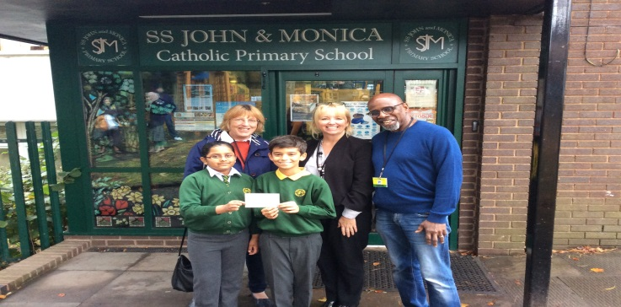
Moseley In Bloom
We were delighted to welcome Moseley in Bloom Trustees, Kate Stocks and Allister Marshall to Ss John and Monica’s who presented the school with a £500 cheque. This money will go towards the development of our prayer garden. As a school, we are always looking for opportunities for foster links with our local community.

Secondary Transfer packs – FINAL REMINDER
Y6 pupils will have received their Secondary Transfer letters and information pack before the holidays. The Local authority asks all parents to apply for their child’s Y7 school place online at http://www.birmingham.gov.uk/schooladmissions between 3rd Sept and 31st October

Christmas Theatre Trips

Each Key Stage will be visiting the theatre again this year to enjoy a Christmas production. Rec/KS1 will be walking to the Midlands Arts Centre as we did last year and KS2 will be travelling by coach to the New Alexandra Theatre in Birmingham. Details of the trips are as follows:

REC/KS1: ‘Rudolf’ on Friday 7th December (Cost: £9.50)

KS2:’Awful Auntie’ (David Walliams) on Thursday 29th November (Cost: £15.33)

For consent and payment log-on to ‘School Money’.

SS John and Martin’s Parish Church and Christmas Fair
This year’s Parish Christmas Fayre will take place in the Parish Hall of St John & St Martin’s Church, George Street, Balsall Heath on Saturday 8th December (12.00 – 2.00 pm). We would like to ask our families to bake cakes that can be sold at the Parish Fayre, in order to raise money for the Parish. Cakes can have a Christmassy theme (or not!) and teachers will judge the best cakes at a special assembly on Friday 7th December. All entrants will receive a small treat and there will be larger prizes for the winning cakes. Put the date in your diary, as it would be wonderful to see as many families as possible supporting this event.

Open Morning
We are holding our school ‘Open Morning’ on Thursday 8th Nov, to give prospective parents an opportunity to visit our school. We will be open from 9.30-11.30am, with the Head Teachers’ address beginning at 9.45am.
Nut- free School
Please note that in order to protect our children who have nut allergies, we are a nut-free school. For this reason, please refrain from including nuts as part of your child’s pack lunch. Thank you.

Congratulations
We wish Mrs Pratty all the very best, as she gets married next week. She will return after the half term break as Mrs Richie!
Poppy Appeal
We are supporting the Royal British Legion’s annual Poppy Appeal again this year. The traditional poppies are 20p and there is a set price list for the other items up to £1.00. Thank you for your support to this worthwhile cause.

Attendance Focus Week - Congratulations to the following pupils who were chosen from our raffle for achieving 100% attendance this week: Reception: Safaa & Ojaswithaa. Year 1: Argun & Serena. Year 2: Felicity & Taio. Year 3: Ekrama & Mohammed. Year 4: Mohammed & Mariatou. Year 5: Mekail & Aiza. Year 6: Abbas & Noah. These children have received a book prize. Stickers were rewarded to all other children who achieved 100% for the week. Well done and keep up the good attendance.

Attendance for the last 2 weeks: Week: 15th-19th Oct – Well done to Year 2 - 100%
Week: 22nd-26th Oct – Well done to Year 1 & 3 - 100%

Class | Reception | Year 1 | Year 2 |  | Year 3 | Year 4 | Year 5 |  | Year 6
% Attendance | 98.6% | 99.8% | 98.4% |  | 99.6% | 97% | 98.9% |  | 93.6%
Lates | 1 | 2 | 2 |  | 4 | 4 | 4 |  | 7
Whole School Attendance so far this year |  |  |  | 97.9% |  | School Target |  | 97%

The Golden Book – The following children have been chosen for exceptional work and behaviour. Well done to everyone!
Reception: Miss Pratty & Miss Morgan | Muawiyah & Poppy
Year 1: Miss Millar & Miss McKeown | Mae & Ivo
Year 2: Miss Geoghegan & Mrs Hodges | Ranell & Chitrani
Year 3: Miss Hodgkinson & Mrs Ali | Ekrama & Zosia
Year 4: Mr Hawker & Mrs Ali | Ariana & Whole Class
Year 5: Mrs Gray & Mrs Mackay | Emmie & Suhaan
Year 6: Mr Ullah & Miss Hill | Haika & Khaleb
Mrs Jena: Deputy Head Teacher | Orestes, Ria & George – Year 6
Mrs Elliott: Head Teacher | Laiq – Reception & Rocco – Year 6

Dates for your Diary
Date | Event | Time
Tues 6th Nov | Year 6 Height and Weight Measurements (School Nurse) | 9.00am
Tues 6th Nov | Parents Consultation Reception/Y6 | 3.30-6.00pm
Wed 7th Nov | Parents Consultation Reception/Y6 | 3.30-6.00pm
Wed 7th Nov | Y4 Buddhist Centre Visit | 10.00am
Thurs 15th Nov | Y1 Mass – All Parents/Carers and Parishioners welcome | 9.00am
Fri 16th Nov | Y3 Class Assembly – All Welcome | 9.15am

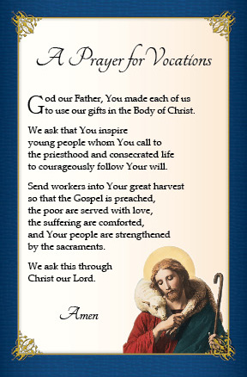
Vocations Week
A big thank you to all parents who volunteered to talk to classes during our Vocations week. The children and staff found the week to be an interesting and exciting one! It reminded us that within our school community, we are all called by God to fulfil a special vocation and we were privileged to hear about the fascinating work some of our parents and carers do.

A huge thank you to Mrs Philips (Felicity and Arlo’s mom) for organising the uniform and cake sale at Parents Evening. Thank you also to Mrs Sanjaya (Aleksander’s mom) for supporting. A total of over £150 was raised, which will go towards school fund. There will be another opportunity to buy uniform at the next Parents Evening in the spring term.

We would like to take this opportunity to wish all our families a restful and happy half-term break!

Please Note School Training Day Monday 5th November. Children return to school Tuesday 6th November

Mrs M. Elliott – Head Teacher

