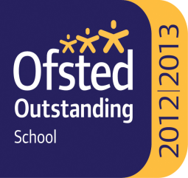

Ss. John & Monica’s Catholic Primary School – Bulletin 14
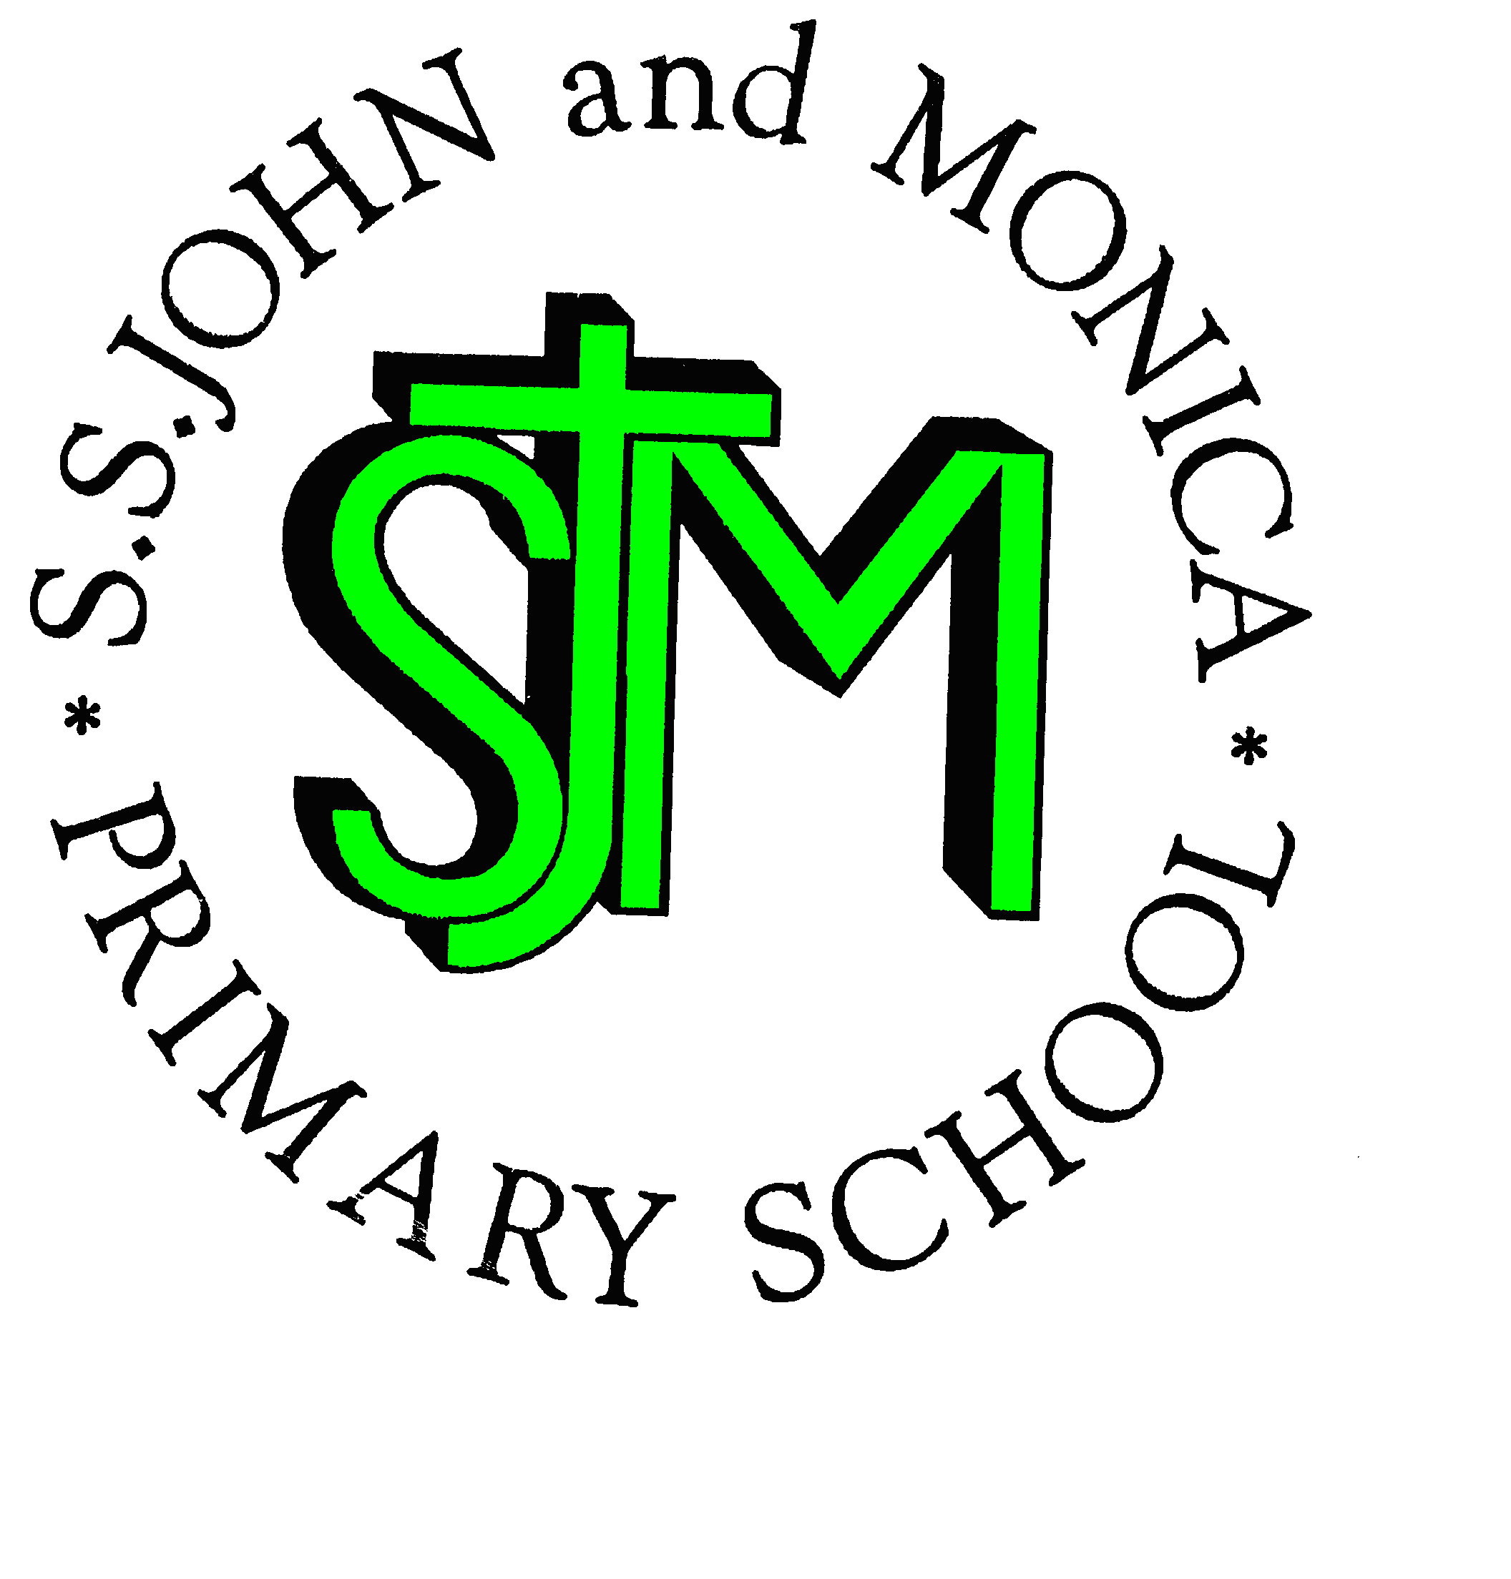

Telephone: 0121 464 5868

Fax: 0121 464 5046
Email: enquiry@stjonmon.bham.sch.uk
Website: www.stjonmon.bham.sch.uk
Twitter: @SSJohnMonicas

Friday 23rd March 2018
Term | Start | Half Term | Reopens | Term Ends
Spring 2018 |  |  |  | Thursday 29th March – 2pm Finish
Summer 2018 | Tuesday 17th April | Monday 28th May | Monday 4th June | Friday 20th July – 2pm Finish  INSET DAYS 23rd & 24th July
INSET
School will be closed to pupils on Monday 16thApril for Staff Training; School will be open to pupils from 8:45am on Tuesday 17th April.

Class Mass

The next school Masses will be celebrated on the following dates and all friends and parishioners are most welcome to attend:

Thursday 26th April at 9:15am prepared by Year 6: The theme of the Mass is Fourth Sunday of Easter

Thursday 3rd May at 9:15am prepared by Year 2: The theme of the Mass is Philip and James the Apostle

.
CAFOD Fundraising Events
Next Week, we will be holding a variety of fun events to raise money for CAFOD appeal. To make payments easier this year, we are asking for a minimum contribution of £2 from each child to take part in all of the events throughout the week. Please send monies in on Monday 26th March to the class teacher. We would like to take this opportunity to thank you in advance for your generosity and support in helping those less fortunate than ourselves. The events that will be taking place throughout the week are listed below:
Class & Event
RECEPTION: Colouring Competition | YEAR 4: Guess the Number of Eggs in the Jar
YEAR 1: Cup-Cake Sale | YEAR 5: Egg Hunt
YEAR 2: Easter Card Competition | YEAR 6: Film afternoon
YEAR 3: Design your own Easter Egg
School Council – Easter Raffle - 20p per ticket
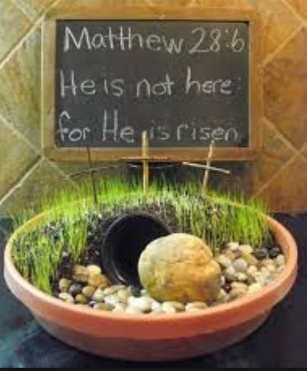
Easter Bonnet Parade
This year we will be holding our Easter Bonnet or Easter Garden Parade on Thursday 29th March,
the last day of the school term. This event is always a huge success and thoroughly
enjoyed by everyone. There will be prizes for the best efforts all round!

School Dinner Payments
School dinner costs will be increasing from £2.25 – £2.30 after the Easter holidays, and will
take effect from Tuesday 17th April.

NSPCC Speak Out . Stay Safe
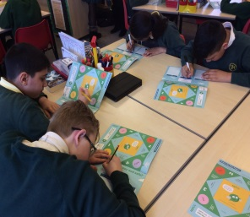
This week Y5 and Y6 pupils participated in the NSPCC Speak Out Stay Safe programme. The workshop teaches the children to understand abuse in all its forms and recognise the signs whilst also informing them on how to protect themselves, thus giving the children the knowledge and understanding they need to stay safe from abuse and neglect.

The following link can provide you with more information for you to discuss with your child at home:
https://www.nspcc.org.uk/services-and-resources/working-with-schools/speak-out-stay-safe-service/

World Book Day Fundraising
We would like to thank you for your generous support for World Book Day! We are pleased to inform you that a total of £160.00 was raised in total which will be donated to Abooku – a UK charity established for the advancement of education of young people in The Gambia. For every pound donated, a Gambian child will receive a complete set of Boabab books.

House Teams: Congratulations to St David’s who are this terms House Cup Winners!
St. Andrews | St. David’s | St. George | St. Patrick
4269 | 4352 | 2817 | 3677

Attendance Winners
Congratulations to the following children who achieved 100% attendance for the Spring Term: Rec: Argun, Fleur, Vincent, Khadija,Amin,Serena,Ivo & Michaela. Y1: Hafsah,Mariyah,Felicity,Zofia,Sean,Hawwa,Hibba,Tegh & Eliza. Y2: Ali,Ekrama, Angela,Khio,Bryan,Bavleen,Aaishah,Talisha,Mariam,Leena,Amanda,Zosia,Mohammed,Mark & Chloe. Y3: Amatalmalik,Mohammed,Shaniya,Raffaele,Foz,Alfred,Gabriel,Davinder,Maria,Aisha & Mariatou. Y4: Efrah, Haider, Mekail,Ellah,George,Mishthi,Ismail,Sara,Subhan,Guneet,Aleezah,Nagarathna,Raul & Mishal. Y5: Esaa,Ismail,George, Haika,Elinor,Sahar,Ada,Mohammed,Elijah,Yusuf & Amera. Y6: Sameer,Dalisha,Zain,Ibrahim,Pen Xian,Juwariyah, Alana & Zain.

Attendance for the last 2 weeks: Week 12th-16th March – Well done to Year 2 99%
Week 19th-23rd March – Well done to Year 4 100%.

Please remember not to book holidays in term time. There will be an Attendance Reward Treat at the end of the year for all those children who have achieved our school target of 97%.
Class | Reception | Year 1 | Year 2 |  | Year 3 | Year 4 | Year 5 |  | Year 6
% Attendance | 95.2% | 89.4% | 98.7% |  | 95.6% | 99.3% | 98% |  | 96.8%
Lates | 5 | 5 | 4 |  | 15 | 9 | 7 |  | 11
Whole School Attendance so far this year |  |  |  | 95.8% |  | School Target |  | 97%

The Golden Book – The following children have been chosen for exceptional work and behaviour. Well done to everyone!
Reception: Miss Pratty, Mrs Shepherd & Mrs Nadeem | Argun Austin & Zoya Hussain
Year 1: Miss Millar & Mrs Hirji | Sean & Kean Hannon & Mariyah Ayoub
Year 2: Mrs Larkin & Mrs Hodges | Angela Amper & Mark Smith Alonso
Year 3: Miss Hodgkinson & Miss Hill | Gabriel Kawala, Eve Alexander & Davinder Kitaure
Year 4: Mr Hawker & Miss Morgan | Subhan Hussain, Aiza Siddique & Sami Ahmed
Year 5: Mr Ullah & Mrs Ali | Ismail Hussain & Yusuf Shafiq
Year 6: Miss Gee, Mrs Gray & Miss McKeown | Talha Aldubai & Haider Razaq
Mrs Jena: Assistant Head Teacher | Alana Vaughan - Y6 & Maria Marouf – Y3
Mrs Elliott: Head Teacher | Year 1 & Kinza Lone-Ebrahim – Y3

Dates for your Diary
Date | Event | Time
Monday 26th March 2018 | Lenten Fundraising for CAFOD and Father Hudson
Tuesday 27th March 2018 | Passover Meal – St John and Martin’s Church | 7.00pm
Wednesday 28th March 2018 | Penitential Service – St John and Martin’s Church | 7.00pm
Thursday 29th March 2018 | Easter Bonnet or Easter Garden Parade & Competition
Thursday 29th March 2018 | Maundy Thursday Evening Mass of the Last Supper – St John and Martin’s Church | 8:00pm
Friday 30th March 2018 | Good Friday Celebration of the Lord’s Passion - St John and Martin’s Church | 3:00pm
Saturday 31st March 2018 | Easter Vigil - St John and Martin’s Church | 8.00pm
Tuesday 17th April 2018 | School re-opens for Summer Term 1 | 8:45am

Holy Week

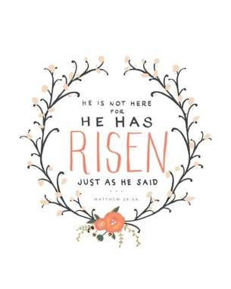
Holy Week begins on Palm Sunday, which is on Sunday 25th March this year. This is the time when we particularly remember the last week of Jesus's life and reflect upon the strength of our own commitment to our faith.

The staff of SS John and Monica Catholic Primary School would like to take this opportunity

to wish you all a very Happy and Holy Easter!

Mrs. M. Elliott

Head Teacher
Mrs E Walker – Executive Headteacher

Mrs E Walker- Executive Headteacher

