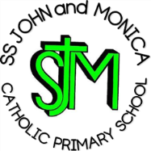
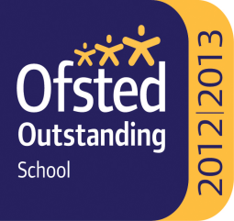

Ss. John & Monica’s Catholic Primary School – Bulletin 19

Telephone: 0121 464 5868

Fax: 0121 464 5046
Email: enquiry@stjonmon.bham.sch.uk
Website: www.stjonmon.bham.sch.uk
Twitter: @SSJohnMonicas

Friday 22nd June 2018
Term | Start | Half Term | Reopens | Term Ends
Summer 2018 |  |  |  | Friday 20th July  2pm Finish
Autumn 2018 | Monday 3rd Sept –Training Day School Opens Tues 4th Sept | Monday 29th Oct | Monday 5th Nov –Training Day School Opens Tues 6th Nov | Friday 21st Dec  2pm Finish

Class Mass

The next school Masses will be celebrated on the following dates and all friends and parishioners are most welcome to attend:

Thursday 28th June at 9:00am prepared by Year 2: St. Peter & St. Paul (28th)

Thursday 5th July at 9:00 am prepared by Year 1: St. Thomas the Apostle (3rd)

First Holy Communion
Please pray for our children who will be receiving the Sacrament of the Eucharist for the first time when they make their First Holy Communion on Sunday 24th June at 10.00am at St John and Martin Church, Balsall Heath. Everyone is most welcome to support the children and their families on this special occasion.

Catholic Sports Athletics
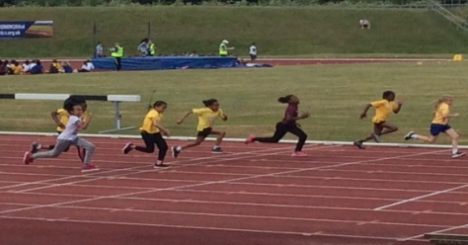
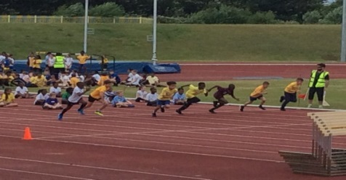
On Monday 18th June, a selection of pupils from Y3, Y4, Y5 and Y6 represented the school at the Birmingham Catholic Schools Athletics event at the Alexander Stadium. We were very proud of the pupils who took part and all that they achieved! Congratulations to:
Y3: Curtis & Mariatou
Y4: Alex & Raul
Y5: Khaleb & Laibah N
Y6: Gursheen, Christian, Dalisha, Talha, Merlina
Mohsin & Sara

Sports Day
On Wednesday 27th June, Sports Day will take place in Moseley Private Park. We would like to invite all parents and family members to come and cheer the children along as they race for their House Team. Please ensure your child has their PE Kit, School cap and water bottle on this day and throughout the warm weather. The times are as follows:
Reception & KS1: 9:30am -10:30am KS2: 11:00am -12:00pm

SOS Banner
You will have noticed the large banner that has been put up outside the school. This is to highlight and show support and solidarity to the Save Our Schools Campaign who are fighting to ensure that the future of our children is not affected by education funding cuts. More information can be found at https://saveourschools.uk/

The Trim Trail
The school Trim Trail has now been fixed and is able to be used once again by pupils. We would like to thank our families for helping to raise the funds to enable this to happen.

Parent Homework Questionnaire
Thank you to all parents who took the time to complete the homework questionnaire. The results are in the process of being analysed and will inform you as to when these will be available on the school website. Thank you for your patience.

Readathon
Due to unforeseen circumstances, Readathon will now run from Monday 25th June until Friday 13th July. Your child will be coming home with their sponsor card on Monday 25th June and you can visit www.readathon.org for more information. We thank you for your continued support and know that the children’s love of reading will help to support those in need.

GDPR (General Data Protection Regulation)
- As you may be aware new data protection regulation came in to force on 25th May. Please click on the link to see a short 5 minute awareness video which explains the changes https://www.youtube.com/watch?v=Ua_LzUJ_wu8&t=1s
- The Pupil and Families Privacy notice is displayed on the school website and can be found at https://www.stjonmon.bham.sch.uk/parents/policies-procedures

National Data Collection
There will be a National Data Collection taking place on Salisbury Road on 29th June; please be aware that this may affect traffic.

School Photographs
The school photographer will be in school on Tuesday 3rd July for the following pupils:
- Families (before school)
- Reception & Y6 only: Individuals and group

Summer Educational Trips
Please ensure that consent forms are returned to the School Office and any outstanding payments are now paid online via the School Money website. If you are having difficulty with any payments, please call the office to make an appointment with myself (Mrs. Elliott) who can discuss this with you further. The summer trip schedule is as follows:

Reception: | Hatton Country Park | Monday 16th July
Year 1: | Ash End House Children’s Farm | Tuesday 17th July
Year 2: | Ironbridge Museum | Friday 29th June
Year 3: | Creation Skatepark | Tuesday 26th June
Year 4: | Wildlife Centre | Friday 29th June
Year 5: | Thinktank: Birmingham Science Museum | Monday 25th June

Attendance for the last 2 weeks: Week 11th-15th June Well done to Year 1 – 90%
Week 18th-22nd June Well done to Year 4 – 99%
Class | Reception | Year 1 | Year 2 |  | Year 3 | Year 4 | Year 5 |  | Year 6
% Attendance | 92.6% | 93.4% | 91.7% |  | 93% | 92.6% | 90% |  | 87%
Lates | 9 | 1 | 1 |  | 10 | 5 | 7 |  | 6
Whole School Attendance so far this year |  |  |  | 95.8% |  | School Target |  | 97%
ATTENDANCE – We are still falling short of our end of year target. It is vitally important that all children are in school every day so that learning is not missed!

The Golden Book – The following children have been chosen for exceptional work and behaviour. Well done to everyone!
Reception: Miss Pratty, Mrs Shepherd & Mrs Nadeem | Michaela & Mayla
Year 1: Miss Millar & Mrs Hirji | Ono & Felicity
Year 2: Mrs Larkin & Mrs Hodges | Chloe & Whole Class
Year 3: Miss Hodgkinson & Miss Hill | Davinder & Whole Class
Year 4: Mr Hawker & Miss Morgan | Mishthi & Sara
Year 5: Mr Ullah & Mrs Ali | Esaa & Noah
Year 6: Miss Gee, Mrs Gray & Miss McKeown | Mohsin & Haider
Mrs Jena: Assistant Head Teacher | Ranell – Year 1 , Khaleb – Year 5 & Ekrama – Year 2
Mrs Elliott: Head Teacher | Shaniya – Year 3 & Rocco – Year 5

Dates for your Diary:

Please also refer to the school website calendar using the following link https://www.stjonmon.bham.sch.uk/calendar
Date | Event | Time
Sunday 24th June | First Holy Communion Mass | 10:00am
Wednesday 27th June | SPORTS DAY | AM
Tuesday 3rd July  Thursday 5th July  Friday 6th July | Y4 Trip to Edgbaston Cricket Ground  Y6 Trip to Edgbaston Cricket Ground  Y5 Trip to Edgbaston Cricket Ground | 9. 00:am-3:00pm
Wednesday 4th July | TRANSITION DAY: Pupils move to new class and meet their teachers | AM ONLY
Wednesday 11th July | Silent Disco Attendance Award

Transition Day

On the morning of 4th July our children we will be moving up to their new classes and meeting their new teachers. Our Y6 children will be visiting their secondary schools and we will be welcoming our new Reception children and families on that morning also. Classes and teachers for next year are as follows:

Reception – Miss Pratty, Y1 – Miss Millar, Y2 – Miss Geoghan, Y3 – Miss Hodgkinson, Y4 – Mr Hawker, Y5 – Mrs Gray & Mrs McKay, Y6 Mr Ullah/Mrs Jena.

We sadly say good bye to Miss Gee, Mrs Larkin and Mrs Austin (currently at St Martin de Porres) who have all given many years of love, dedication and service to our school. We wish them well as they move on to pastures new.

We welcome Miss Geoghan who completed her teacher trainee placement at our school in Y1 in the Spring Term as a newly qualified teacher. We also welcome teachers Mrs Goddard and Mr Davis who will be covering Planning, Preparation and assessment time and PE across the school
“It is when we are in transition that we are most completely alive” – William Bridges

Mrs M.Elliott – Head Teacher
Mrs E Walker – Executive Headteacher

Mrs E Walker- Executive Headteacher

