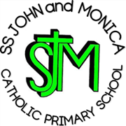
SS John & Monica’s Catholic Primary School – Bulletin 5

Telephone: 0121 464 5868

Fax: 0121 464 5046
Email: enquiry@stjonmon.bham.sch.uk
Website: www.stjonmon.bham.sch.uk
Twitter: @SSJohnMonicas

Friday 16th November 2018
Term | Start | Half Term | Reopens | Term Ends
Autumn 2018 |  |  |  | Fri 21st Dec - 2pm Finish
Spring 2019 | Mon 7th Jan 2019 | Mon 18th Feb | Mon 25th Feb | Thurs 11th April – 3.15pm Finish  Training Day Friday 12th April
Summer 2019 | Mon 29th Apr | Mon 27th May | Mon 3rd June | Fri 19th Jul – 2pm Finish

Class Masses

The next school Mass will be celebrated on Wed 21st Nov– Year 4 (St Cecilia) at 9.00am - Please note the change of date for the Year 4 Mass. Mass the following week will be at the normal time on Thurs 29th Nov – Year 3 (St Andrew the Apostle) at 9.00am. Parents, friends and parishioners are most welcome to attend.

Section 48 Religious Education Inspection
We have been informed that we will be having a Religious Education Inspection on Tues 20th and Wed 21st Nov. It is five years since the last Section 48 inspection and we were aware that the inspection would likely take place this term. We are fully prepared for the visit and are looking forward to welcoming the Inspectors to Ss John and Monica’s, to show them the high standards of provision of Catholic Life, Collective Worship and RE in our school. A Mass will be held on Wednesday 21st at 9.00am (lead by Year 4). We look forward to seeing as many parents/carers there as possible to support the children.

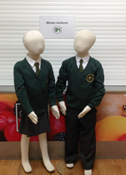
Important - Winter Uniform
A reminder that all pupils should be wearing in school their winter uniform. This is a white shirt (not polo shirt) and tie, bottle green jumper/cardigan and grey skirt/trousers. Tights and socks should either be white, grey or black. Sensible shoes not boots or trainers should be worn. Ties can be purchased at the school office for £2.50. Thank you to all parents who follow our School Uniform Policy.

PE Bags
It has been noticed that some children are bringing their PE kits in rucksacks not PE bags. This means that there is little room for coats to be hung on pegs as well, often resulting in them falling onto the floor. This is a trip hazard and one we wish to avoid. Please ensure that your child brings their kit in a PE type Bag (either a school bought one or other). School bags are available at the school office priced £4.20. Thank you for your co-operation.

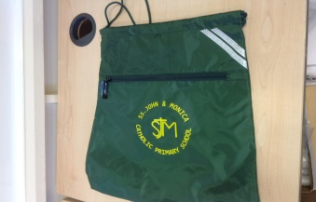

Parents Evening
Thank you for all the positive comments from parents/carers who came to our Parents Evening before half term. It was lovely to be able to chat to so many of you. We do listen to your comments and are continually striving to improve provision. We wish to give you advance notification that there will be a slight change for the Spring Term Parents/Carers consultations. These will take place on the following dates:
Monday 1st April 3.30-6.00pm
Tuesday 2nd April 3.30-6.00pm
All appointments will be 10 minutes in length. Thank you.

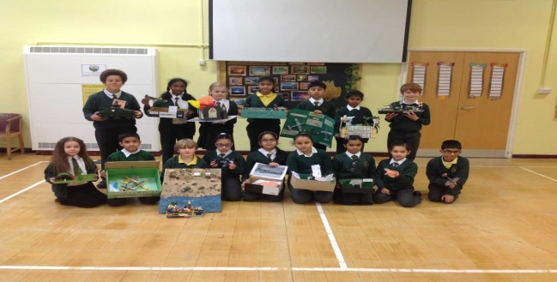
Year 5 History Topic
I had the pleasure of seeing all the wonderful projects that Year 5 pupils had completed for homework over half term holidays. Their History topic is World War II and all pupils were set the task to do some reading about the topic and bring in the fruits of their research. There was such a variety of interesting work, including 3D models, scrap books and drawings. Well done Year 5!

Christmas Theatre Trips

Each Key Stage will be visiting the theatre again this year to enjoy a Christmas production. Rec/KS1 will be walking to the Midlands Arts Centre as we did last year and KS2 will be travelling by coach to the New Alexandra Theatre in Birmingham. Details of the trips are as follows:

REC/KS1: ‘Rudolf’ on Friday 7th December (Cost: £9.50)

KS2:’Awful Auntie’ (David Walliams) on Thursday 29th November (Cost: £15.33) – Please note children will return to school at approx. 4.15pm

Please be aware of the deadline – Friday 23rd November for the above trips. If payments are not made, these trips are in danger of being cancelled. For consent and payment log-on to ‘School Money’.

SS John and Martin’s Parish Church and Christmas Fair
This year’s Parish Christmas Fayre will take place in the Parish Hall of St John & St Martin’s Church, George Street, Balsall Heath on Saturday 8th December (12.00 – 2.00 pm). We would like to ask our families to bake cakes that can be sold at the Parish Fayre, in order to raise money for the Parish. Cakes can have a Christmassy theme (or not!) and teachers will judge the best cakes at a special assembly on Friday 7th December. All entrants will receive a small treat and there will be larger prizes for the winning cakes. Put the date in your diary, as it would be wonderful to see as many families as possible supporting this event.

Faith-filled and Hopeful
This term’s Virtues are Faith-filled and Hopeful. As a school we are continually asking ourselves the following questions: How do we build up the faith of our pupils and community? How do we really put Christ at the centre of everything we do?
This term we will be thinking about how we can demonstrate these virtues in our lives.

School Gates
Unfortunately, there was a road traffic accident last week which resulted in our electronic gates being damaged. I have been in regular contact with the police over the incident and we will be able to claim for damages from third party insurance. It may, however, take a few weeks to resolve and get new gates fitted. Please be careful supervising children when collecting them from school.
Dinner Money
Can you please ensure that school dinner money payments are up-to-date. Any dinner money arrears over £20 will result in parents being requested to send in packed lunches until the arrears have been paid. Please go to:
https://eduspot.co.uk/product/schoolmoney/

Attendance
I am pleased to see that we are slightly above our attendance target of 97% - I hope this continues. At a recent Governors meeting, we discussed our current policy regarding attendance rewards including, Attendance focus week, certificates and end of year target reward. The Governors agreed with the importance of promoting and rewarding good attendance and were happy to endorse current attendance rewards, including an end of year reward for all those who had achieved 97%. Where there are significant and persistent medical issues, the school will look at each case individually and work with families as appropriate.

Attendance for the last 2 weeks: Week: 6th-9th Nov – Well done to Year 6 - 100%
Week: 12th-16th Nov – Well done to Year 6 - 100%

Class | Reception | Year 1 | Year 2 |  | Year 3 | Year 4 | Year 5 |  | Year 6
% Attendance | 99% | 98.8% | 97% |  | 98.4% | 95.8% | 98.6% |  | 100%
Lates | 3 | 8 | 3 |  | 7 | 4 | 6 |  | 5
Whole School Attendance so far this year |  |  |  | 97.9% |  | School Target |  | 97%

The Golden Book – The following children have been chosen for exceptional work and behaviour. Well done to everyone!
Reception: Miss Pratty & Miss Morgan | Callum & Sehar
Year 1: Miss Millar & Miss McKeown | Maurice & Ibrahim
Year 2: Miss Geoghegan & Mrs Hodges | Ali & Yanet
Year 3: Miss Hodgkinson & Mrs Ali | Khio & Kai
Year 4: Mr Hawker & Mrs Ali | Haniyah, Saarah, Jemima & Rio
Year 5: Mrs Gray & Mrs Mackay | Aiza & Subhan
Year 6: Mr Ullah & Miss Hill | Elinor & Laaibah H
Mrs Jena: Deputy Head Teacher | Maysa & Madeeha – Year 6
Mrs Elliott: Head Teacher | Alf – Year 6 , Eve – Year 4 & Whole Class Year 2

Dates for your Diary
Date | Event | Time
Monday 19th Nov | Y2 Visit to St John and Martin’s Church | 1.30pm
Thurs 22nd Nov | Y6 Visit to St John and Martin’s Church | 1.30pm
Fri 23rd Nov | Enabling Enterprise Challenge Day – Whole School | All Day
Mon 26th - Fri 30th Nov | Attendance Focus Week
Mon 26th - Fri 30th Nov | Parliament Week
Mon 26th Nov | Reception Class Eye Tests | 1.30pm
Mon 26th Nov | Y5 Visit St John and Martin’s Church | 1.30pm
Wed 28th Nov | Y3 Visit to the Synagogue | 10.00am
Wed 28th Nov | Nasal Flu-Sprays Rec - Y5 | All Day
Thurs 29th Nov | KS2 Theatre Visit to New Alexander Theatre | 1.30pm – Return 4.15pm
Fri 30th Nov | Year 3 Class Assembly – Parents/Carers welcome | 9.15am
Poppy Appeal
Thank you for your generous support towards our Poppy Appeal. All funds will go to the Royal British Legion to support the armed force community. We finished the week by holding a Remembrance Assembly to remember all those who sacrificed their lives for our freedom and to remember those who are currently victims of war.
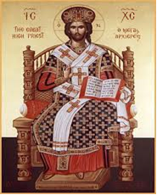

Advent Fundraising
Each year band will be raising money during our annual Advent appeal week beginning 17th- 21st Dec. Monies raised will go towards CAFOD and other local and national charities. On Thursday 20th Dec we invite all children to come to school in their Christmas Jumpers and bring in £1.00 which will go towards school fund.

Christ The King 25th November

Mrs M. Elliott – Head Teacher

Christ the King
23rd November

