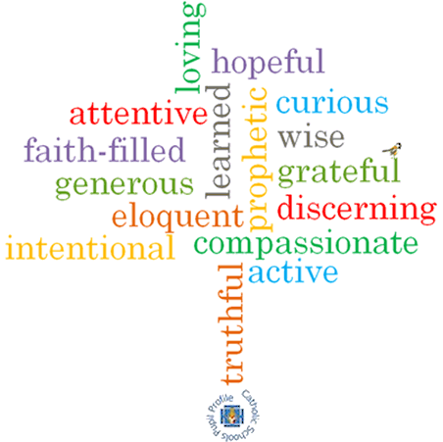
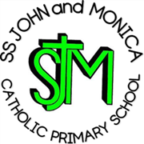
SS John & Monica’s Catholic Primary School – Bulletin 3

Telephone: 0121 464 5868

Fax: 0121 464 5046
Email: enquiry@stjonmon.bham.sch.uk
Website: www.stjonmon.bham.sch.uk
Twitter: @SSJohnMonicas

Friday 12th October 2018
Term | Start | Half Term | Reopens | Term Ends
Autumn 2018 |  | Mon 29th Oct | Mon 5th Nov –Training Day School Opens  Tues 6th Nov | Fri 21st Dec - 2pm Finish
Spring 2019 | Mon 7th Jan 2019 | Mon 18th Feb | Mon 25th Feb | Thurs 11th Apr – 3.15pm Finish  Training Day Friday 12th April
Summer 2019 | Mon 29th Apr | Mon 27th May | Mon 3rd June | Fri 19th Jul – 2pm Finish

Class Masses

The next school Mass will be celebrated on Wed 17st Oct – Year 3 (St Luke the Evangelist) at 10.45am and Thurs 25th Oct – Year 6 (Vocations – Year of Priests) at 9.15am. Parents, friends and parishioners are most welcome to attend.

Parents Evening for Years 1 to 5 only
Parents Evening will take place on Thursday 25th October. You will have received an email/text regarding how to book an appointment on-line. If you do not have access to a computer, please ring the school office where we can manually book an appointment for you. There will be a second hand Uniform Sale on the evening, kindly organised by Mrs Phillips (Arlo and Felicity’s Mom). All proceeds to go to school fund. Thank you to all parents who have generously donated uniform.

KS2 Break Time Toast
From Monday 15th Oct we will be offering our KS2 children the opportunity to purchase toast at break time. This will be for a trial period up until Christmas. The cost will be 20p per slice. Should you wish for your child to take up this offer, please send in money on a daily basis as and when you wish.

Christmas Theatre Trips

Each Key Stage will be visiting the theatre again this year to enjoy a Christmas production. Rec/KS1 will be walking to the Midlands Arts Centre as we did last year and KS2 will be travelling by coach to the New Alexandra Theatre in Birmingham. Details of the trips are as follows:

REC/KS1: ‘Rudolf’ on Friday 7th December (Cost: £9.50)

KS2:’Awful Auntie’ (David Walliams), on Thursday 29th November(Cost: £15.33)

For consent and payment log on to ‘School Money’.

School Library
The school library is open every Tuesday from 3.15-4:00pm. Pupils and parents from both Key Stages are welcome . This is a wonderful opportunity for parents to support us in promoting a love of reading and we would like to encourage you to visit whenever you are able.

Photographer
The photographer will be in school onTuesday 16th October to take family, individual and Reception/ Y6 Class Photographs. If you would like a family photography please arrive at school no later than 8.30am. Thank you.

Walking To/Home from school
October is ‘Walk to School’ month and we encourage our children to walk to school as much as possible. If parents drive to school, we encourage you to park away from school and walk the last part. As usual, we would like to remind parents that after the half-term break pupils are not allowed to walk home alone due to the dark nights. Parents will need to make arrangements to collect their child at the end of the school day or following an after-school club; this includes Year 6 pupils who would normally have permission to walk alone.

Free School Meals - IMPORTANT

Please complete the Free School Meals Application Form, which was sent via email as soon as possible. If you are entitled to Free School Meals (even if you are sending a packed lunch into school with your child), we urge you to complete the paperwork and provide evidence at the school office. This is because a £1,320 grant is awarded to schools for each child eligible for free school meals.

Vocations Week 22nd-26th Oct

As you already know, we are holding our Vocations week from 22nd-26th Oct. If you would like to get involved in the week, please speak to your child’s class teacher. During the week, classes will be ‘tweeting’ their experiences of learning about Vocations @SSJohnMonicas .

Erasmus Project
Mr Ullah will be visiting Sweden for the week beg 22nd-26th Oct as part of the European Erasmus Exchange Programme. He will be observing outstanding practice in teaching and learning and will be sharing these observations with staff on his return.
Open Morning
We are holding our school ‘Open Morning’ on Thursday 8th Nov, to give prospective parents an opportunity to visit our school. We will be open from 9.30-11.30am, with the Head Teachers’ address beginning at 9.45am

Holidays in Term Time
We would like to politely remind parents that holiday in term time is not allowed under Government regulations for school attendance. Pupils have 175 days off school each year and there is an expectation that holiday will be booked in these periods. The impact of taking time off is significant for pupils of all ages. Any term time holiday it will be recorded as unauthorised absence and will make it difficult for your child to stay above the 90% that is needed before external agencies/legal processes start to become involved.

Attendance for the last 2 weeks: Week 1st-5th Oct – Well done to Rec & Year 3 – 99.3%. Week 8th-12th Oct – Well done to Year 2 – 99.3%.
Class | Reception | Year 1 | Year 2 |  | Year 3 | Year 4 | Year 5 |  | Year 6
% Attendance | 98% | 98.8% | 98% |  | 98.5% | 98% | 98% |  | 97.2%
Lates | 0 | 2 | 2 |  | 1 | 13 | 5 |  | 5
Whole School Attendance so far this year |  |  |  | 97.8% |  | School Target |  | 97%

The Golden Book – The following children have been chosen for exceptional work and behaviour. Well done to everyone!
Reception: Miss Pratty & Miss Morgan | Sakina & Jayden
Year 1: Miss Millar & Miss McKeown | Mayla & Evan
Year 2: Miss Geoghegan & Mrs Hodges | Bailey & Felicity
Year 3: Miss Hodgkinson & Mrs Ali | Lucas, Vladislava & Leena
Year 4: Mr Hawker & Mrs Ali | Eve, Gabriel, Ryan & Denae
Year 5: Mrs Gray & Mrs Mackay | Guneet & Haider
Year 6: Mr Ullah & Miss Hill | Orestes & Alzubir
Mrs Jena: Deputy Head Teacher | Alima – Year 4 & Maysa – Year 6
Mrs Elliott: Head Teacher | Rayyan – Year 5 & Noah – Year 6

Dates for your Diary
Date | Event | Time
Mon 15th Oct | Y2 Inspire Workshop – A representative for each child to attend | 9.15am
Wed 17th Oct | Y6 Inspire Workshop – A representative for each child to attend | 9.15am
Fri 19th Oct | Active Curriculum Day- All PE Kit in school | All Day
Mon 22nd-26th Oct | VOCATIONS WEEK
Thurs 25th Oct | Parents Evening Y1, Y2, Y3,Y4, Y5 | 3.30-7.30pm
Fri 26th Oct | Break Up for Oct Half Term | 3.15pm

Please Note School Training Day Monday 5th November. Children return to school Tuesday 6th November

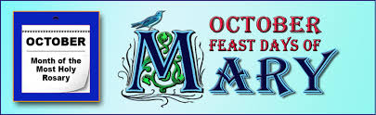

Mrs M.Elliott – Head Teacher

