SS John & Monica’s Catholic Primary School
Calculations Policy

Introduction
The aim of this policy is to provide teachers, support staff, parents and pupils with an easy to follow guide about the use of informal and formal written methods in mathematics. The use of the word calculation is expected in all discussion rather than the word sum (which is mathematical vocabulary for total and can be misleading). This document is to be read in conjunction with the Mathematics Policy.

The National Curriculum (2013) provides some guidance for teachers in the use of “traditional” written methods. As a school we are keen to support the development of a range of secure, efficient strategies that are easy for the pupils to understand and ensure clarity in mathematics recording. Pupils are given a firm grounding in practical, oral and mental mathematical skills from their entry in EYFS which are practised regularly.

At all stages pupils use the skills of estimation, rapid recall of known facts, jottings and mental maths skills to aid their understanding of calculation. At the heart of successful calculation is pupil understanding of number, place value (partitioning and value) and the vocabulary of the 4 operations. Teachers should ensure that this understanding is secured and consolidated at each Year group so that pupils are confident and analytical. Teachers will display key maths vocabulary in their classrooms and will remind children to use maths sense when talking about their calculations.

Children should be equipped to decide when it is best to use a mental, written or calculator method based on the knowledge that they are in control of this choice as they are able to carry out all three methods (mental/oral, written or calculator) with confidence.

Guidance from the NCETM
Research taken from the NCETM suggest that these areas are crucial in developing children’s fluency when calculating and is therefore discussed in more detail with examples below:
• Develop children’s fluency with basic number facts
• Develop children’s fluency in mental calculation - Calculation Guidance: NCETM October 2015
• Develop children’s fluency in the use of written methods
• Develop children’s understanding of the = symbol
• Teach inequality alongside teaching equality
• Don’t count, calculate
• Look for pattern and make connections
• Use intelligent practice
• Use empty box problems
• Expose mathematical structure and work systematically
• Move between the concrete and the abstract
• Contextualise the mathematics
• Use questioning to develop mathematical reasoning
• Expect children to use correct mathematical terminology and speak in full sentences
• Identify difficult points

Develop children’s fluency with basic number facts
Fluent computational skills are dependent on accurate and rapid recall of basic number bonds to 20 and times-tables facts. At SS John and Monica we aim to spend a short time every day on these basic facts, as research suggests that this quickly leads to improved fluency. This can be done using simple whole class chorus chanting. This is an important step to developing conceptual understanding through identifying patterns and relationships between the tables (for example, that the products in the 6× table are double the products in the 3× table). This helps children develop a strong sense of number relationships, an important prerequisite for procedural fluency.
We encourage children to learn their multiplication tables in this order to provide opportunities to make connections:
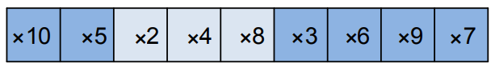
Develop children’s fluency in mental calculation
Efficiency in calculation requires having a variety of mental strategies. In particular we recognise the importance of 10 and partitioning numbers to bridge through 10.
For example: 9 + 6 = 9 + 1 + 5 = 10 + 5 = 15.
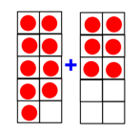
Specialist teachers from Shanghai refer to this as “magic 10”. It is helpful to make a 10 as this makes the calculation easier.
Develop fluency in the use of formal written methods
Teaching column methods for calculation provides the opportunity to develop both procedural and conceptual fluency. However, we ensure children understand the structure of the mathematics presented in the algorithms, with a particular emphasis on place value. Children who are struggling with place value explore grouping objects in order to count them and come to the conclusion that grouping in tens is easy to count. They make base ten from resources such as straws, then Unifix cubes, prior to being introduced to structured base ten equipment.
Informal methods of recording calculations are an important stage to help children develop fluency with formal methods of recording. However, only used for a short period, to help children understand the internal logic of formal methods of recording calculations. They are stepping stones to formal written methods.
For example.
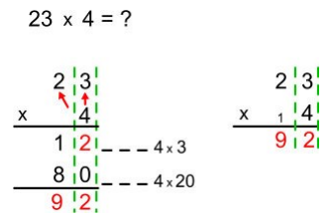

Develop children’s understanding of the = symbol
The symbol = is an assertion of equivalence. If we write:
3 + 4 = 6 + 1
Then we are saying that what is on the left of the = symbol is necessarily equivalent to what is on the right of the symbol. But many children interpret = as being simply an instruction to evaluate a calculation, as a result of always seeing it used thus:
3 + 4 = 5 × 7 = 16 – 9 =
If children only think of = as meaning “work out the answer to this calculation” then they are likely to get confused by empty box questions such as:
3 + □ = 8
Later they are very likely to struggle with even simple algebraic equations, such as:
3y = 18
One way to model equivalence such as:
2 + 3 = 5 is to use balance scales (see illustrations below). Teachers should vary the position of the = symbol and include empty box problems from Year 3 to deepen children’s understanding of the = symbol.
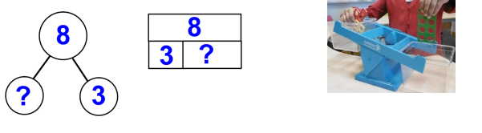
Teach inequality alongside teaching equality
To help young children develop their understanding of equality, they also need to develop understanding of inequality. From Y2 inequality should be taught before, or at the same time as, equality. One way to introduce the < and > signs is to use rods and cubes to make a concrete and visual representations such as:
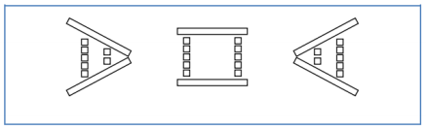
to show that 5 is greater than 2 (5 > 2), 5 is equal to 5 (5 = 5), and 2 is less than 5 (2 < 5). Balance scales can also be used to represent inequality.
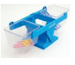

Incorporating both equality and inequality into examples and exercises helps children develop their conceptual understanding.
For example, in this empty box problem children have to decide what the missing symbol is :
5 + 7 □ 5 + 6
An activity like this encourages children to develop their mathematical reasoning: “I know that 7 is greater than 6, so 5 plus 7 must be greater than 5 plus 6” and shows depth of understanding. Asking children to decide if number sentences are true or false also helps develop mathematical reasoning. For example, in discussing this statement:
4 + 6 + 8 > 3 + 7 + 9
a child might reason that “4 plus 6 and 3 plus 7 are both 10. But 8 is less than 9. Therefore 4 + 6 + 8 must be less than 3 + 7 + 9, not more than 3 + 7 + 9”.
In both these examples the numbers have been deliberately chosen to allow the children to establish the answer without actually needing to do the computation. This emphasises further the importance of mathematical reasoning and the importance of careful selection of numbers chosen by teachers when setting tasks
Don’t count, calculate
Young children benefit from being helped at an early stage to start calculating, rather than relying on ‘counting on’ as a way of calculating. For example, with a sum such as:
4 + 7 =
Rather than starting at 4 and counting on 7, children could use their knowledge and bridge to 10 to deduce that because 4 + 6 = 10, so 4 + 7 must equal 11.
Look for patterns and make connections
Here at SS john and Monica teachers use concrete resources (models) and visual representations (images) of the mathematics (See additional guidance). Understanding, however, does not happen automatically, children need to reason by and with themselves and make their own connections (not be shown or told by the teacher). Children should get into good habits early (at least from Year 1) in terms of reasoning and looking for patterns and connections in the mathematics. The question “What’s the same, what’s different?” should be used frequently to make comparisons. For example “What’s the same, what’s different between the three times table and the six times table?”
Use intelligent practice
Children should engage in a significant amount of practice of mathematics through class- and homework exercises. However, in designing practice exercises for lessons, the teacher is advised to avoid mechanical repetition and to create an appropriate path for practising the thinking process with increasing creativity (Gu, 1991). The practice that children engage in should provide the opportunity to develop both procedural and conceptual fluency. Children should be required to reason and make connections between calculations. The connections made improve their fluency.
For example:
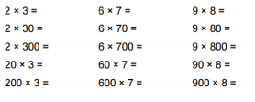
Use empty box problems
Empty box problems are a powerful way to help children develop a strong sense of number through intelligent practice. They provide the opportunity for reasoning and finding easy ways to calculate. They enable children to practise procedures, whilst at the same time thinking about conceptual connections.
A sequence of examples such as:
3 + □ = 8
3 + □ = 9
3 + □ = 10
3 + □ = 11
helps children develop their understanding that the = symbol is an assertion of equivalence, and invites children to spot the pattern and use this to work out the answers.
This sequence of examples does the same at a deeper level:
3 × □ + 2 = 20
3 × □ + 2 = 23
3 × □ + 2 = 26
3 × □ + 2 = 29
3 × □ + 2 = 35
Children should also be given examples where the empty box represents the operation, for example:
4 × 5 = 10 □ 10
6 □ 5 = 15 + 15
6 □ 5 = 20 □ 10
8 □ 5 = 20 □ 20
8 □ 5 = 60 □ 20
These examples also illustrate the careful use of variation to help children develop both procedural and conceptual fluency.
Expose mathematical structure and work systematically
Developing instant recall alongside conceptual understanding of number bonds to 10 is important. This can be supported through the use of images such as the example illustrated below
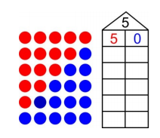
The image lends itself to seeing pattern and working systematically and children can connect one number fact to another and be certain when they have found all the bonds to 5. Using other structured models such as tens frames, part whole models or bar models can help children to reason about mathematical relationships.
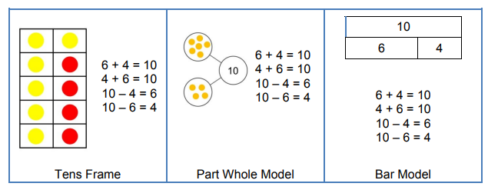
Connections between these models should be made, so that children understand the same mathematics is represented in different ways. Asking the question “What’s the same what’s different?” has the potential for children to draw out the connections. Illustrating that the same structure can be applied to any numbers helps children to generalise mathematical ideas and build from the simple to more complex numbers, recognising that the structure stays the same; it is only the numbers that change. For example:
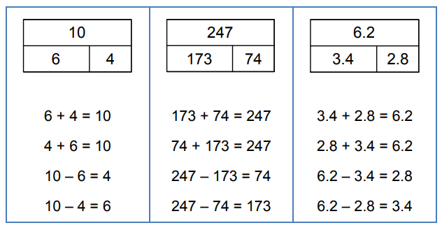

Move between the concrete and the abstract
Children’s conceptual understanding and fluency is strengthened if they experience concrete, visual and abstract representations of a concept during a lesson. Moving between the concrete and the abstract helps children to connect abstract symbols with familiar contexts, thus providing the opportunity to make sense of, and develop fluency in the use of, abstract symbols. For example, in a lesson about addition of fractions children could be asked to draw a picture to represent the sum Alternatively, or in a subsequent lesson, they could be asked to discuss which of three visual images correctly represents the sum, and to explain their reasoning:
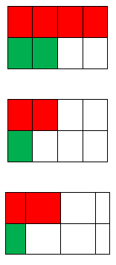

Using other structured models such as tens frames, part whole models or bar models can help children to reason about mathematical relationships.
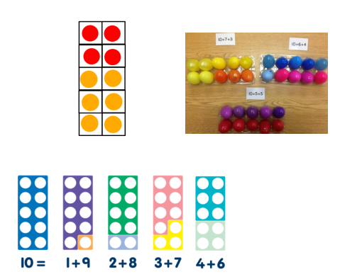
Contextualise the mathematics
A lesson about addition and subtraction could start with this contextual story:
“There are 11 people on a bus. At the next stop 4 people get on. At the next stop 6 people get off. How many are now on the bus?”
This helps children develop their understanding of the concepts of addition and subtraction. But during the lesson the teacher will keep returning to the story. For example, if the children are thinking about this calculation 14 – 8 then the teacher should ask the children: “What does the 14 mean? What does the 8 mean?”, expecting that children will answer: “There were 14 people on the bus, and 8 is the number who got off.” Then asking the children to interpret the meaning of the terms in a sum such as 7 + 7 = 14 will give a good assessment of the depth of their conceptual understanding and their ability to link the concrete and abstract representations of mathematics
Use questioning to develop mathematical reasoning
Teachers’ questions in mathematics lessons are often asked in order to find out whether children can give the right answer to a calculation or a problem. But in order to develop children’s conceptual understanding and fluency there needs to be a strong and consistent focus on questioning that encourages and develops their mathematical reasoning. This can be done simply by asking children to explain how they worked out a calculation or solved a problem, and to compare and contrast different methods that are described.
Children quickly come to expect that they need to explain and justify their mathematical reasoning, and they soon start to do so automatically – and enthusiastically. Some calculation strategies are more efficient teacher here scaffold children’s thinking to guide them to the most efficient methods, whilst at the same time valuing their own ideas.
Rich questioning strategies include:
• “What’s the same, what’s different?” In this sequence of expressions, what stays the same each time and what’s different
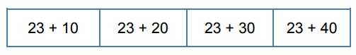
Discussion of the variation in these examples can help children to identify the relationship between the calculations and hence to use the pattern to calculate the answers.
“Odd one out”
Which is the odd one out in this list of numbers: 24, 15, 16 and 22?
This encourages children to apply their existing conceptual understanding. Possible answers could be: “15 is the odd one out because it’s the only odd number in the list.” “16 is the odd one out because it’s the only square number in the list.” “22 is the odd one out because it’s the only number in the list with exactly four factors.”
If children are asked to identify an ‘odd one out’ in this list of products: 24 × 3 36 × 4 13 × 5 32 × 2 they might suggest: “36 × 4 is the only product whose answer is greater than 100.” “13 × 5 is the only product whose answer is an odd number.”
• “Here’s the answer. What could the question have been?”
Children are asked to suggest possible questions that have a given answer.
For example, in a lesson about addition of fractions, children could be asked to suggest possible ways to complete this sum:
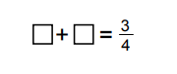
• Identify the correct question
Here children are required to select the correct question:
A 3.5m plank of wood weighs 4.2 kg
The calculation was: 3.5 ÷ 4.2
Was the question:
a. How heavy is 1m of wood?
b. How long is 1kg of wood?
• True or False
Children are given a series of equations are asked whether they are true or false:
4 × 6 = 23 4 × 6 = 6 × 4 12 ÷ 2 = 24 ÷ 4 12 × 2 = 24 × 4
Children are expected to reason about the relationships within the calculations rather than calculate • Greater than, less than or equal >, <, or =
3.4 × 1.2 3.4 5.76 5.76 ÷ 0.4 4.69 × 0.1 4.69 ÷ 10
These types of questions are further examples of intelligent practice where conceptual understanding is developed alongside the development of procedural fluency. They also give pupils who are, to use Ofsted’s phrase, rapid graspers the opportunity to apply their understanding in more complex ways.
Expect children to use correct mathematical terminology and to express their reasoning in complete sentences
The quality of children’s mathematical reasoning and conceptual understanding is significantly enhanced if they are consistently expected to use correct mathematical terminology (e.g. saying ‘digit’ rather than ‘number’) and to explain their mathematical thinking in complete sentences.
Identify difficult points
Difficult points need to be identified and anticipated when lessons are being designed and these need to be an explicit part of the teaching, rather than the teacher just responding to children’s difficulties if they happen to arise in the lesson. The teacher should be actively seeking to uncover possible difficulties because if one child has a difficulty it is likely that others will have a similar difficulty. Difficult points also give an opportunity to reinforce that we learn most by working on and through ideas with which we are not fully secure or confident. Discussion about difficult points can be stimulated by asking children to share thoughts about their own examples when these show errors arising from insufficient understanding. For example:
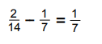
A visualiser is a valuable resource since it allows the teacher quickly to share a child’s thinking with the whole class
White Rose Maths
As a school we adapt the small steps and suggested problems and activities taken from the White Rose Maths Hub. We have also adapted our calculations based on the recommendations they suggest. Here is a basic calculation policy that outlines the concrete, pictorial and abstract approach we use in school. Here you can also find more detailed guidance as to the approach to using the four operations to calculate for each year group – this is adapated from the NCETM.
Website
For further detail how to complete various formal calculations as well as how to use concrete and pictorial representations please see our website. Here you will find short video clips of the children in each year group completing these calculations.

Policy Adopted: Mar 2019
To Be Reviewed: Mar 2021

