SS John and Monica Catholic Primary School

Relationships and Health Education

A Guide for Parents and Carers
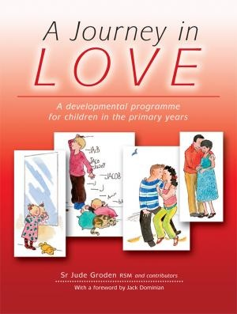

Aims of Relationship and Health Education
- To encourage pupils’ growth in self-respect, acknowledging we are all created in the image and likeness of God

- To help pupils develop an understanding that love is the central basis of relationships

- To help pupils to understand the nature of relationships and to encourage them to reflect on their own relationships and respect differences between people.

- To develop pupils’ confidence in talking, listening and thinking about feelings and relationships.

- To help pupils acquire the skills necessary to develop and sustain relationships

- To ensure that pupils protect themselves and ask for help and support when needed.

- To ensure that pupils are prepared for puberty.

- To help pupils to develop a healthier, safer lifestyle.

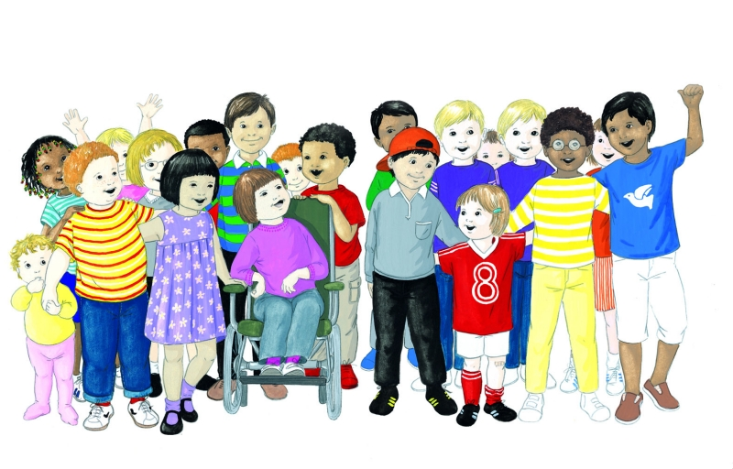
- To prepare pupils to play an active role as citizens and to understand the Catholic vision of what it means to be citizens of the Kingdom/reign of God.

Our Mission Statement places these aims and beliefs at the Centre of all we hope to achieve…

‘At SS John and Monica’s we Learn through the example of Jesus to Love, Respect, Understand and Value each other’

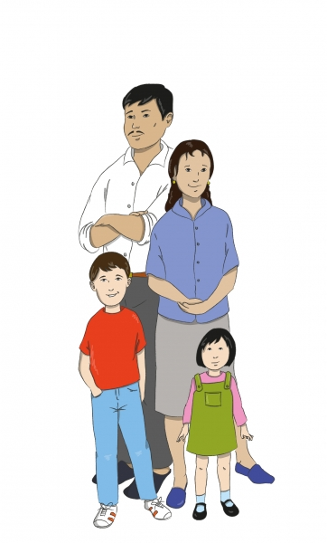
It is with this mission that we share this booklet with our parents and carers. We recognise parents as the first and most important educators of their children and we hope that the information provided here will enable us all to work together in supporting parents in their most important role.

Love…
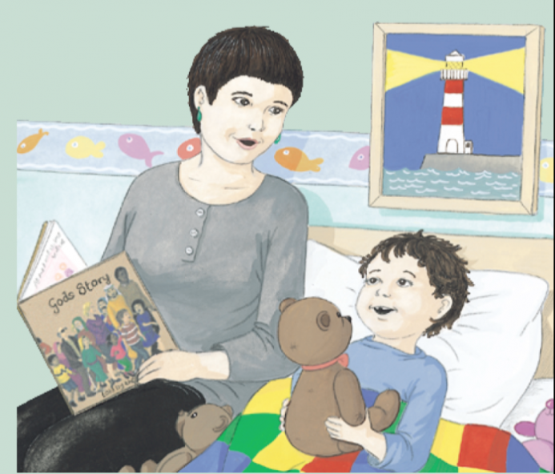
At the heart of Christian faith is love: St. John says that God is love (1 John 4:9) and the whole purpose of Christianity is to live it as fully as possible in and through love. This means that we have to link every aspect of our being, from birth to death, with love.

Love starts to enter our life from the moment of birth when we are held tenderly in the arms of our mother and developed throughout our first intimate relationship of childhood with our parents, family members, friends and teachers.
At puberty, sexual characteristics develop and we begin to seek someone outside of the family with whom we can grow in love, usually ending in marriage.

The whole purpose of education at home and in our primary school is to connect every aspect of growth, physical, emotional, intellectual and social with love. The ultimate goal is to enable adults to fully love themselves (to accept themselves positively) and in turn love their neighbour (making themselves fully available to others).

Through our love for others, we link ourselves with God the Father, through Jesus Christ his Son, and through the Spirit.

The programme for Relationships and Sex Education which we have chosen to share at SS John and Monica’s is called ‘A Journey in Love’. This booklet for parents and carers outlines how the programme is organised and what is covered in each year group.
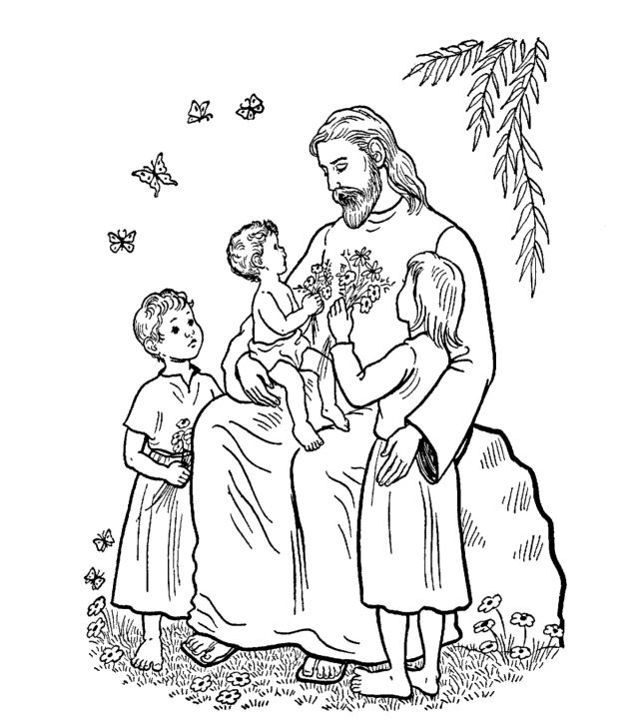
A Journey in Love has at its foundation the belief that we are made in the image and likeness of God, and as a consequence, gender and sexuality are God’s gift, reflect God’s beauty and share in the divine creativity.

In order that children may grow and develop healthily and as complete human beings, they must have an understanding of their gender and the implications for successful relationships, they must be at ease with themselves and grow in self-knowledge.

A different aspect of the mystery of love is explored in each year group and all are encouraged to marvel at the wonder and beauty of God’s creative love. The is reflected in each stage of a person’s growth, through a series of lessons with activities and reflections which focus on physical, social, emotional, intellectual and spiritual development.

Themes explored in each year group…
Nursery Wonder at God’s Love

Reception God loves each of us in our uniqueness

Year One We meet God’s love in our family

Year Two We meet God’s love in the community

Year Three How we live in love

Year Four God loves us in our differences

Year Five God loves me in my changing and development

Year Six The wonder of God’s love in creating new life
How will we organise lessons for Journey in Love?
- before the programme begins ground rules are set with the children regarding the kind of positive behaviour expected of every child,
- all children and teachers treat each other with respect, all questions and answers are listened to in a sensitive and sensible manner,
- any child who is silly, or disruptive and who deliberately attempts to embarrass or hurt another member of the group will be asked to leave,
- children may be taught in small groups for some elements of the programme
- some lessons may be taught in single sex groups as appropriate,
- all children will cover the same topics,
- lessons may include; discussions, presentations, questions, written work, homework

What if a child asks a difficult question?
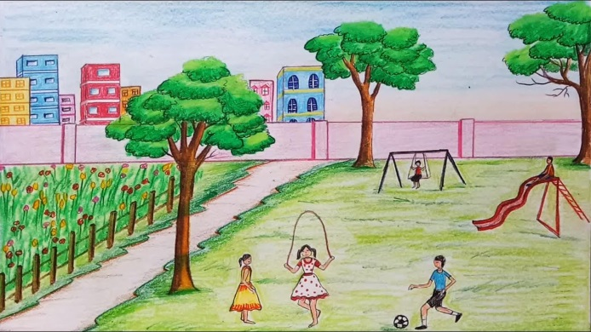
There are specific areas that we feel should not be discussed within the context of our school lessons, as we feel that our children are not yet emotionally mature to handle these issues. These are all topics which are dealt with at secondary school.

If a child does ask a question outside the scope of our programme it will be dealt with in a sensitive and caring manner. We would always ask the child concerned to discuss the issue with his/her parents.

How can I help?
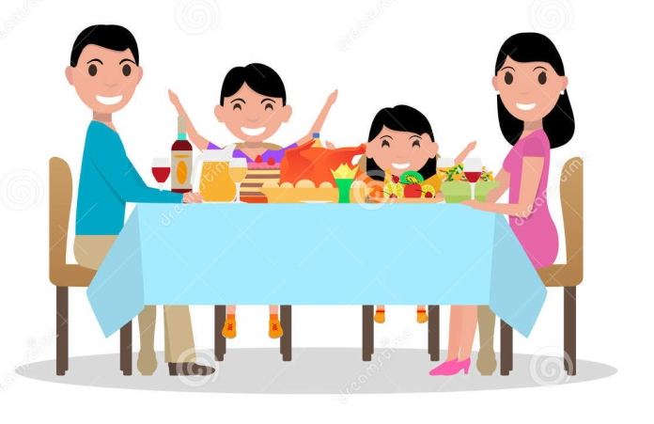
- by talking with your child at home,
- by discussing their work after each lesson
- by listening to any concerns,
- by reassuring your child that you are there if they need to talk about anything at all,
- by helping with homework activities,

What if I don’t feel that my child is ready for this programme of work?
We ask that if parents feel that their child may not be quite ready for the content within the programme, they should make an appointment with the Headteacher to discuss their thoughts on the matter.

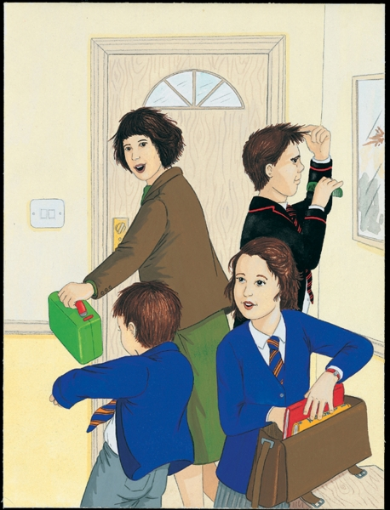

Nursery - Wonder at God’s love
Children begin to know and understand that they are part of the wonder of God’s love and creation.

Key Words: God, wonder, love, creation, hands, fingers, nails, faces, noses, lips, ears, hair, features, colour, shape, size

Physical Children focus on their hands e.g. size, length of fingers, nails. They focus on each other’s eyes and note the colour and shape, they look at their faces and whole body shapes, size, shape and features.

Social Children look at their pictures and discuss how they are the same/ different and that each one is special. They discover how many boys and girls there are in the class and divide into groups for a play activity.

Emotional Children begin to observe and become sensitive to facial expressions. They focus on individual expressions and discover the beauty of their smile.

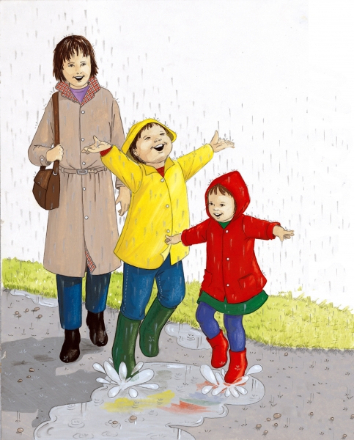
Intellectual Children focus on the cause of happy and sad feelings and identify the signs of feeling happy and sad. They look at expressions in photographs.

Spiritual Children focus on the wonders of God’s world, e.g. people, animals, trees, land, seas etc. They see their special place as part of the wonder of God’s creation.

They share scripture:
‘You created every part of me;
And put me together in my mother’s womb. Psalm 139:13

Reception – God loves each of us in our uniqueness
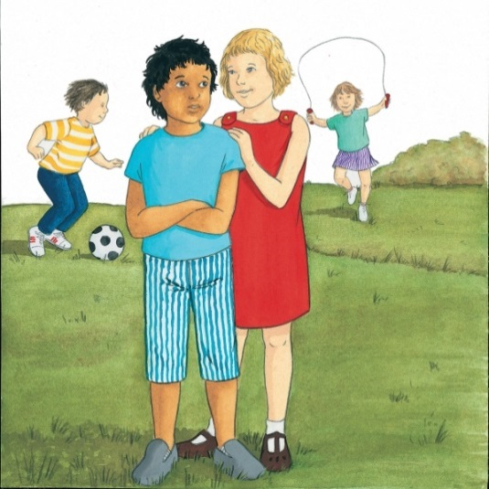
Children know and understand that God has made them unique and that although we are all different we are all special to him.

Key words: God, unique, different, special, eyes, hair, boy/girl, hands, fingers, name, family, love, womb, describe

Physical Does it matter if we are all different? How are we different?

Social Who do I play with at school and why does he/she play with me? Explore favourite games.

Emotional Explore how we feel about our friends at home and at school. Explore why we play with them.

Intellectual Explore why it is important to have friends and describe a good friend.

Spiritual To consider: Is Jesus our friend? To share the story from scripture ‘Jesus welcomes the little children’ and talk about children being special to God.
Who is the Mother of Jesus? Why is she special? To know that Jesus grew for nine months in Mary’s womb.
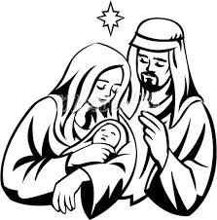
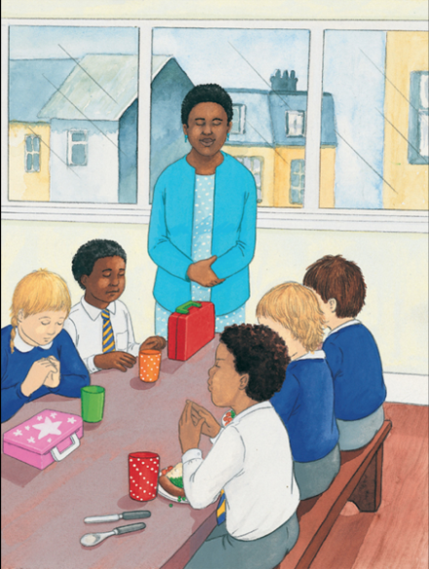
Year One – We meet God’s love in our family

Children know and understand that they are growing and developing as members of their own family and God’s family.

Key words: unique, friend, God, important, different, special

Physical Who is in my family? E.g. mother, father, brothers, sisters, grandparents etc.
How many children have babies in their families? Babies come in all sizes, some have long legs, some have hair, some without etc.
Talk about how fast babies change and grow and ask at home about themselves as a baby.

Social Invite the children to share their home research
Parents share the wonder and excitement of these moments of growth and development for them.

Emotional What are the happiest moments in your family? E.g. birthdays, christenings, weddings.
What are the saddest moments in your family? E.g. death of pets, leaving home.
How is love shown in your family?

Intellectual Why do we need to grow up in families? What happens if you grow up without a family? Would it be a happy experience? What would you miss? How would life be different?

Spiritual We are members of God’s family. How were we born into God’s family?
What special title do we give to God as members of God’s family? E.g. Our Father, Jesus our Brother, Holy Spirit, our friend and Guide.
Year Two – We meet God’s love in the community

Children know and understand that they are growing and developing in a God-
given community.

Key words: God, community, belonging, family, father/mother, carer/guardian,
feelings, emotions

Physical Do you belong to a community? E.g. school, Parish, a club etc. What other community do you belong to? How do you belong to these communities?

Social Is belonging to a community important?
What do we receive from the community we belong to? What do we give to the community we belong to?

Emotional How does a community help us to develop our feelings and emotions? Are we always happy in our community? Are we, as a community sometimes sad or upset?

Intellectual Could people feel alone even though they belong to a community? What would they miss out on? What are the advantages of being on your own?

Spiritual If God is called ‘Our Father’ what does that make us?
As children of God how should we treat each other?
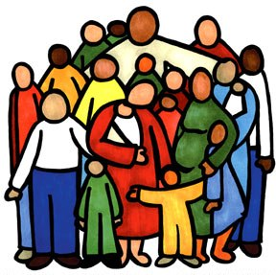
Year Three – How we live in love

Children know and understand the virtues essential to friendship, e.g. loyalty, responsibility… and experience the importance both of forgiving and being forgiven and of celebrating God’s forgiveness.

Key Words: God, forgiveness, health, safe, exercise, relationships, community, alone, lonely, personal space

Physical Who takes care of me? How do I look after myself? E.g. safety, crossing the road, healthy eating etc.
How am I changing?

Social How do I keep myself safe? How do I help others to make and keep friends? How do I take care of others?

Emotional How do you feel when a friend is not there for you?
How do your friends feel when you are not there for them?
How can you be a more supportive friend?

Intellectual Can you recognise the difference between being alone and being lonely?
Recognise the need for personal privacy e.g. personal space

Spiritual Explore the story of Zacchaeus who was an outcast. Jesus
accepted him as a friend, welcomed and forgave him.
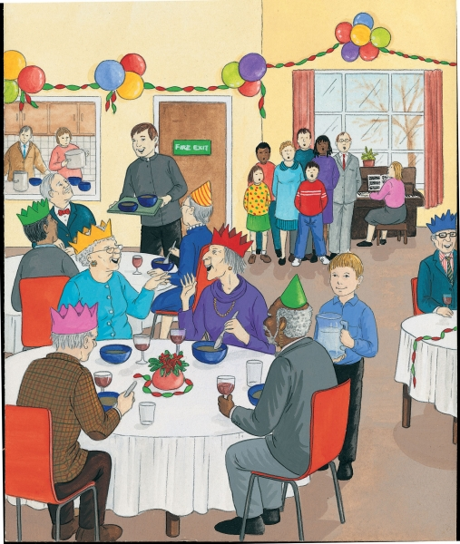
How can I forgive and include others as Jesus did?
Write on a card what you like about your friend and share this. Take the card home and keep it in a special place.
Year Four – God loves us in our differences

Children know and understand that they are all different and celebrate these differences as they appreciate that God’s love accepts us as we are and as we change.

Key words: God, gifts, talents, difference, development, change, male and female body parts, conflict, appreciate, celebrate, achievement

Physical Continue to recognise that all pupils grow and develop at a different rate
Name the different male and female body parts and introduce their various functions.
Identify the development of the baby in the womb.

Social How do I learn to accept and celebrate who I am?
How do I accept difference in others?
How do I deal with difference and manage the conflicts that arise?

Emotional How do I appreciate my own gifts, talents, achievements and all that makes me unique?
How do I appreciate others and the gifts they have been given?
How do I deal with the natural, negative emotions that present themselves?

Intellectual Can I identify and name my feelings? Do I understand what these feelings are? How do I deal with what I feel, and can I analyse my feelings and actions?

Spiritual St. Paul’s teaching on love…
Love is patient and kind; it is not jealous or conceited or proud;
Love is not ill-mannered or selfish or irritable;
Love does not keep a record of wrongs;
Love is not happy with evil, but is happy with the truth.
Love never gives up: and its faith, hope and patience never fail.
1 Corinthians 13:4-7
Year Five – God loves me in my changing and development

Children become aware of the physical and emotional changes that accompany puberty – sensitivity, mood swings, anger, boredom, etc. and grow further in their understanding of God’s presence in their daily lives.

Key words: God, sensitivity, puberty, presence, celebrate, external, internal, change, develop, ovulation, reproduction, production, hormones, menstruation

Physical and intellectual
Identify and celebrate the ways I have changed since birth
Discuss the external and internal changes which happen to boys and girls in puberty.
Girls: breasts develop, hips broaden, waist slims, ovaries produce oestrogen, hormonal activity, menstruation, growth of hair etc.
Boys: production of testosterone, muscles develop, voice deepens, waist thickens, longer limbs, wet dreams and erections, penis and scrotum enlarge, growth of hair, production of sperm, adam’s apple enlarges etc.
Recognise that sexual development is a natural part of human growth and that
physical changes from child to adult means the ability and potential to become a mother or father.

Social and Emotional
Recognise behaviour changes as we grow up. Expectations are different and are often dependent on our experiences, and treatment by others, and our view of the world in which we live.
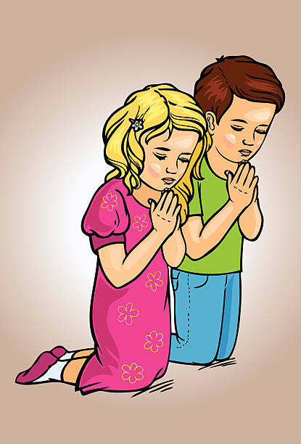
Reflect on the ways to become more sensitive to the emotional development of oneself and others.

Spiritual
Ask children to share their understanding of change
through poetry, prayer, art etc. Share with each other and
celebrate the wonder of change.
Year Six – The wonder of God’s love in creating new life

Children develop in an appropriate way for their age, an understanding of sexuality and grow further in their appreciation of their dignity and worth as children of God.

Key Words: God, Christian, appropriate, dignity, sexuality, intercourse, fallopian, conceive, relationship, uterus, cervix, marriage, fiancé, fiancée, sperm duct, bladder, prostate gland, penis, testicle, ovary, uterus, vagina,

Physical Explain how human life is conceived
Look at the illustrations of the organs of the human body, including male and female reproductive organs.
Understand how a child grows within the mother’s womb.

Emotional Relationships develop and eventually you may be able to use the word love. This has to be explained: real love reveals itself in complete commitment. Often we use the word love too casually, the claim to love someone is a momentous one.
Without love, relationships will fail because living with another human being means that they will find out exactly what you are like; what kind of person you are.
It comes back to the kind of person you are, and what qualities you bring to that relationship.

Social Recognise and compile a list of the signs of love expressed in those around us. E.g. signs of love between those who care for us
Reflect on the different degrees of friendship that exist e.g. school friends, close school friends, best friends, mixed gender friends, life-long friends.

Spiritual Understand that God causes new life to begin through the love that parents have for each other.
Celebrate God’s creative love in creating us as his children and recognise that we grow as human beings to the extent we give and receive love. The on-going understanding of marriage is living out love.
As Christians we can appreciate the sheer wonder of the sexual act. God created the incredible natural process by which husband and wife bring new life into the world. The church celebrates all this in the Sacrament of Marriage.

We praise and thank you, Lord, for gifts of life and love.
Help us to use these wisely as we continue to journey in love.

