SS John & Monica Catholic Primary School
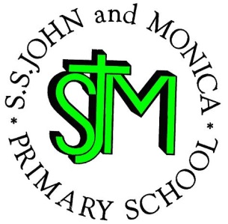
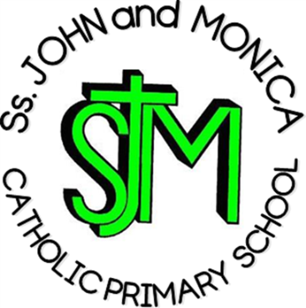
Headteacher:
M. Elliott (B.Ed. Hons., NPQH)
Chantry Road
Moseley
Birmingham B13 8DW

Telephone: 0121 464 5868
Fax: 0121 464 5046
Email: enquiry@stjonmon.bham.sch.uk
Website: www.stjonmon.bham.sch.uk
Twitter: @SSJohnMonicas @2014Erasmus

Friday 3rd May 2019

Dear Parents and Carers,

The start of this term is a very important time, as Y6 prepare themselves for the SAT’s tests. Please find below a reminder of some important points to remember during this time.

Punctuality and Attendance:
Year 6 is a very important year and any time missed due to lateness and/or absenteeism can have a profound effect on the end of year levels that your child will achieve. 95% attendance is the same as 9 days off school and this can be between 35 and 40 lessons not taken. (Imagine how much work can be missed in 40 lessons!) Children should make every effort to be in school every day this year. Children should be on time, lessons begin as soon as register is completed and lateness results in missed introductions where key ideas are delivered. Please help us to help your child achieve their potential! Appointments should be made outside school hours wherever possible. The whole school target is 97%

In Year 6 children are expected to achieve certain levels that reflect the appropriate level of attainment for a child at 11 years old. It is important for you to be aware of these levels to ensure you can support your child at their level of ability:

LEVEL | MEANING
Working at greater depth | Your child is working above age related expectations
Working at the expected standard | Your child is working at age related expectations
Working towards the expected standard | Your child is working towards the expected level for an 11 year old

Children will be constantly informed of their progress and how to develop those areas to improve their standards of achievement. Children should be doing revision every night using materials provided by school.

Homework:
This term the homework will be revision, allocated homework tasks and SAT’s past papers. Children are partly responsible for their eventual levels and must take this responsibility seriously. Where possible, children should access the internet for extra revision and extension activities. Mathletics is a great resource to increase confidence in maths skills.

Following SATs, Y6 pupils will be required to learn singing and acting parts for their end of year production and will be set homework online as well as project work.

Please support the topic areas studied by encouraging library visits and Internet usage for some self-study at home.

After the SATs tests, Y6 pupils will be working to develop further their writing skills across a range of subjects and genres, including: Persuasive Writing, Narrative Writing and Poetry

It is imperative that children continue to read on a daily basis throughout the summer term covering a wide range of fiction and non-fiction texts. We will continue to develop the following reading skills: Give and/or explain the meaning of words in context; retrieve and record information and identify key details from fiction and non-fiction; summarise main ideas from more than one paragraph; make inferences from the text; explain and justify inferences with evidence from the text; predict what might happen from details stated and implied; identify and explain how meaning is enhanced through choice of words and phrases; and make comparisons within a text.

Numeracy:
Children will apply, develop and consolidate their mental and written strategies to solve problems and challenges involving all areas of the maths curriculum.
RE: This term we will be studying Pentecost, Belonging to the Church Community and Celebrating the Life of Mary & the Saints
Science: Children will learn about Light.
PE: PE will be focusing on Invasion Games, Athletics and Outdoor Adventurous Activities (PGL) Please make sure your child their PE Kit in school every day as we will be having additional PE sessions this term. All children are required to participate unless there is a medical reason preventing this, and must have a note that explains this from a parent or doctor.
Research: Pupils should continue to complete work in their independent research books, considering ways in which to present their research creatively and in varying forms for the following topics:
History: Ancient Greece
SEAL & PHSE: Children will be focusing on two topics this term. The first is the SRE Programme: a Journey in Love, The PSHE topics for this term are Relationships and Changes.

Y6 Pupils will also working very hard this term preparing for their end of year production, which will require pupils to develop their music, drama and speaking & listening skills

Additional Dates:
Monday 6th May Bank Holiday
Tuesday 7th May – School Photographer (Families at 8.30am)
Monday 13th May –Year 6 SATS Week (all children invited to breakfast club free of charge)
Friday 17th May – Picnic in the park (weather depending)
Monday 20th May Library Visit
Wednesday 5th June – Bell Heath Residential
Friday 7th May –Return from Bell Heath
Tuesday 18th June – Transition Workshop
Wednesday 19th June – Sports Day
Wednesday 3rd July – Enabling Enterprise trip to Prologis
Wednesday 10th July _ Mosque Visit
Friday 12th July – Year 6 Assembly
Thursday 18th July – Year 6 Mass
We would very much like to promote the participation of parents on our class trips; if you are interested in accompanying Y6 on future trips, please speak with a member of the Y6 team.

We have a very busy and fun term ahead, and we know that we can rely on you to support the school in ensuring that your child reaches their potential and is fully prepared for Year 7.

With Kind Regards

Mr Ullah, Mrs Jena and Miss Hill

