SS John & Monica Catholic Primary School
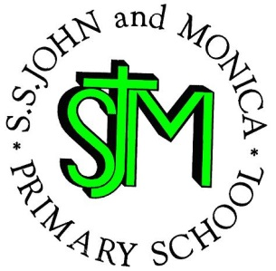
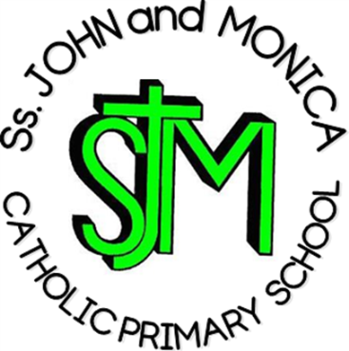
Headteacher:
M. Elliott (B.Ed. Hons., NPQH)

Chantry Road
Moseley
Birmingham B13 8DW

Telephone: 0121 464 5868
Fax: 0121 464 5046
Email: enquiry@stjonmon.bham.sch.uk
Website: www.stjonmon.bham.sch.uk
Twitter: @SSJohnMonicas @2014Erasmus

Happy New Year!
Dear Parents and Carers,

This letter contains information that will assist you during the run up to SAT’s. Please keep it somewhere safe for reference during this term. If you have any concerns please feel free to speak to me informally in the playground or make an appointment through the school office for a longer discussion.

Punctuality and Attendance:
Year 6 is a very important year and any time missed due to lateness and/or absenteeism can have a profound effect on the end of year levels that your child will achieve. 95% attendance is the same as 9 days off school and this can be between 35 and 40 lessons not taken. (Imagine how much work can be missed in 40 lessons!) Children should make every effort to be in school every day this year. Children should be on time, lessons begin as soon as register is completed and lateness results in missed introductions where key ideas are delivered. Please help us to help your child achieve their potential! Appointments should be made outside school hours wherever possible. The whole school target is 97%

In Year 6 children are expected to achieve certain levels that reflect the appropriate level of attainment for a child at 11 years old. It is important for you to be aware of these levels to ensure you can support your child at their level of ability:

LEVEL | MEANING
GREATER DEPTH | Your child is working above age related expectations
EXPECTED | Your child is working at age related expectations
WORKING TOWARDS | Your child is working towards the expected level for an 11 year old

Children will be constantly informed of their progress and how to develop those areas to improve their standards of achievement. Children should be doing revision every night using materials provided by school or that can be purchased from the school office

Homework:
This term the homework will be revision, allocated homework tasks and SAT’s past papers. Children are partly responsible for their eventual levels and must take this responsibility seriously. All homework the children receive is written in their homework log. Each day children are also encouraged to revise misconceptions and errors from the day if we have used SATS papers.

So far, there has been a varied response to homework. More conscientious members of Year 6 are meeting their deadlines and doing a great job, some pupils are either not handing work in on time or not at all. Children who fail to hand in homework will miss playtimes to complete the work. It is essential that homework is done – some every evening is advisable to ensure that skills are revised.

Where possible, children should access the internet for extra revision and extension activities. Mathletics is a great resource to increase confidence in maths skills. Revision sites such as KS2 BBC bitesize are good for interactive games and quizzes in English, Maths and Science and are all age a topic appropriate. NRich is also a fantastic website to challenge pupils and develop their mathematical reasoning and problems solving skills.

Please support the topic areas studied by encouraging library visits and Internet usage for some self-study at home.

Literacy:
- Extended writing: Descriptive Writing, Persuasive Writing, Narrative Writing, Instructional Writing, and Myths & Legends
- Reading skills: Give and/or explain the meaning of words in context; retrieve and record information and identify key details from fiction and non-fiction; summarise main ideas from more than one paragraph; make inferences from the text; explain and justify inferences with evidence from the text; predict what might happen from details stated and implied; identify and explain how meaning is enhanced through choice of words and phrases; and make comparisons within a text. Our class novel this term is Kensuke’s Kingdom by Michael Morpurgo.
It is imperative that children are reading on a daily basis and covering a wide range of fiction and non-fiction texts.
- Grammar and Spelling Rules: Children have revision guides which they should refer to at home and use a revision tools

Numeracy:
Children will be studying Mental Strategies, Fractions & Percentages, Algebra & Patterns, Statistics and Geometry in the first half of the Spring Term. We will then be revising all Year 5 and 6 topics throughout Spring Term 2.

- Maths tests will be sent home for homework as well as the homework books we have used throughout the year. These tests will have been already completed in class and questions your child got wrong or areas of weakness will be highlighted. Children are to focus on their areas of weakness when revising not areas in which they are already confident.
- Pupils will also be given Arithmetic papers to complete at home on a weekly basis. They can use the annotated and marked paper completed in class to support them with this at home.

Science: Topics to be taught this term are Light, Electricity and Evolution

RE: Followers of Christ, Baptism & Celebration of the Holy Spirit, Prayer, Lent and Holy Week.

PE: PE will take place on Thursday afternoons. The children will be studying games with a focus on Hockey. Please make sure your child has the correct kit in school for the term. All children are required to participate unless there is a medical reason preventing this, and must have a note that explains this from a parent or doctor.

This will be a hard working term and we know that we can rely on you to support the school in ensuring that your child reaches their potential and is fully prepared for Year 7.

Additional Dates
Y6 Mass – 7th February/ 11th April
Parents Evening – 1 and 2nd April

With Kind Regards

Mr Ullah and Mrs Jena

