SS John & Monica Catholic Primary School
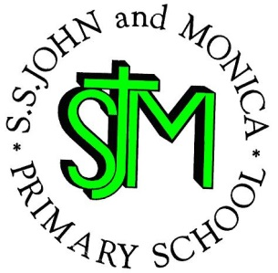
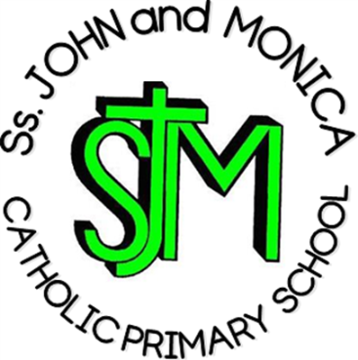
Headteacher:
M. Elliott (B.Ed. Hons., NPQH)

Chantry Road
Moseley
Birmingham B13 8DW

Telephone: 0121 464 5868
Fax: 0121 464 5046
Email: enquiry@stjonmon.bham.sch.uk
Website: www.stjonmon.bham.sch.uk
Twitter: @SSJohnMonicas @2014Erasmus

Curriculum Information Letter – Spring 2019

Dear Parents/Guardians,

We would like to welcome you back to school. We hope that you and your family have had an enjoyable break. In this letter you will find an overview of the work that your child will be completing during this term. Please find opportunities to support your child’s learning by doing additional research on any new topics.

RE | We will complete 4 units from our scheme ‘Learning and Growing as the People of God’ this term: Christmas, Jesus – Light of the World and Beloved Son, Jesus Teaches us How to Pray, and Lent.  Mass takes place on Thursday mornings and the first Year 4 Mass will take place on Thursday 24th January. We hope that you will be able to join us in our celebrations.
English | Reading: This term, the children in Year 4 are reading ‘The Lion, the Witch and the Wardrobe’ by C. S. Lewis. In addition, the children will cover a range of texts (both fiction and non-fiction) for comprehension-based activities, so please do encourage your child to explore different genres in order to complement their learning.  Writing: The children will be taught a range of writing genres (fiction and non-fiction) based on our key texts. They will predominantly be focusing on narrative fiction, but other genres will include: play-scripts, recounts and poetry.  Grammar, Punctuation and Spelling:  Grammar, punctuation and spelling will be taught from the Programme of Study for Year 4.
Maths | In Year 4, we are learning all about the following:  Number and Place Value; Addition & Subtraction; Multiplication & Division; Fractions (including Decimals); Measurement; Geometry (Properties of Shape, Position and Direction) and Statistics.  Please support your child with learning their times tables regularly as they will be tested weekly and will aid much of their mathematical learning.
Science | This term, we are learning all about states of matter.
Computing | Throughout this term, we will be focusing on coding and debugging a series of algorithms.
PE | PE will occur every Wednesday in the afternoon. Please ensure your child has the correct PE kit (t-shirt, shorts &/or tracksuit, pumps for indoor PE and trainers for outdoor PE). Your child’s kit should be kept in school and washed every half-term. A letter should be provided if your child is unable to participate in PE for a medical reason.
Music | Guitar lessons will take place in school every Monday afternoon. Please ensure your child has their guitar with them every week.
French | Children will develop their understanding of spoken French and will work towards using spoken language with confidence and accuracy.
History & Geography | This half-term, we will be looking at volcanoes. Afterwards, our focus shifts from history to what it was like for children in WW2.
Art & Design Technology | Our artistic focus for this term is Pop Art, which will be taught cross-curricular. We will be looking at the works of collective artists, including Andy Warhol and Roy Lichtenstein. The children will be designing & knitting a spider web (linking into our class text, ‘Charlotte’s Web’).

Homework | Reading: Each child will read on a daily basis in either whole class sessions, small groups or individually. Reading records will be checked daily to ensure home reading is taking place. Please read with your child every day and sign their reading diary. Reading books must be brought to school every day.  Spelling: Weekly spelling lists will be given out on Fridays and tested the following Friday.  Times Tables: All times tables up to 12 should be learnt by the end of Year 4. Further to this, children should know the inverse operations for each multiplication calculation.  Other: Mathletics and Reading Eggs homework will be set each week on a Friday and should be completed and returned the following Friday, unless requested for a specific date.
Attendance and Punctuality | This year we have a school target of 97% for pupils in Years 1 – 6. It is very important that your child attends school every day that they are fit and well. Pupils with an attendance score of less than 90% are regarded by the Government as having Persistent Absence and parents will be invited into school. All pupils who achieve an attendance of 97% or more will be invited to the Annual Attendance Reward Visit for excellent attendance!
Other Information | Mass: Thursday 24th January  Mass: Thursday 28th March  Parents’ Evening: Monday 1st April and Tuesday 2nd April

If you have any questions please speak to me informally in the playground at the end of the day or make an appointment with through the school office.

Yours sincerely,

Mr Hawker and Mrs Ali

