SS John & Monica Catholic Primary School

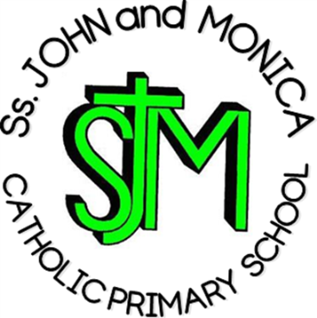
Headteacher:
M. Elliott (B.Ed. Hons., NPQH)

Chantry Road
Moseley
Birmingham
B13 8DW

Telephone: 0121 464 5868
Fax: 0121 464 5046
Email: enquiry@stjonmon.bham.sch.uk
Website: www.stjonmon.bham.sch.uk
Twitter: @SSJohnMonicas @2014Erasmus

Curriculum Information Letter – Autumn 2018

Dear Parents,

We would like to welcome you back to school. We hope that you and your family have had an enjoyable holiday. In this letter you will find an overview of the work that your child will be completing during this term. Please find opportunities to support your child’s learning by doing additional research on any new topics.

RE | We shall be completing 4 units from our scheme ‘Learning and Growing as the People of God’ this term: Creation and the story of Abraham to Joseph, Jesus teaches us how to pray, Advent and Christmas.  Mass takes place on Thursday mornings and the first Year 4 Mass will take place on Thursday 20th September. We hope that you will be able to join us in our celebrations.
English | Reading: This term, Year 4 are reading ‘James and the Giant Peach’ by Roald Dahl. If possible, please encourage your child to enjoy other stories by Dahl in order to gain a breadth of knowledge about the author.  Writing: The children will be taught a range of writing genres (fiction and non-fiction) based on our key texts. Genres include: narrative fiction, instructions, newspaper reports, biographies and narrative poetry.  Grammar, Punctuation and Spelling:  Grammar, punctuation and spelling will be taught from the Programme of Study for Year 4.
Maths | This term, our areas of focus will be:  Number and Place Value, Addition & Subtraction, Multiplication & Division, Reasoning and Problem Solving.  Please support your child with learning/practicing their times tables regularly as this will be tested weekly and will aid much of their mathematical learning.
Science | This half-term, we are learning all about Electricity. After half-term, our focus will move onto Sound.
Computing | Throughout this term, we will be focusing on how to stay safe online and coding and debugging a series of algorithms.
PE | PE will occur every Wednesday in the afternoon and will be taught by Mr. Davis. Please ensure your child has the correct PE kit. Your child’s kit should be kept in school and washed every half-term. A letter should be provided if your child is unable to participate in PE for a medical reason. Topics for this term include Dance and Gymnastics.  A PE Kit checklist will be carried out on 11th September. Please ensure all required kit in in school by this date.
Music | Guitar lessons will take place in school every Monday afternoon. Please ensure your child has their guitar with them every week.
French | Children will develop their understanding of spoken French and will work towards using spoken language with confidence and accuracy.
History & Geography | This half-term, we will be looking at the Anglo-Saxons, Scots and Picts. Afterwards, our focus shifts from history to Volcanoes.
Art & Design Technology | Our artistic focus for this year is the work of Andy Warhol. We will also be completing a range of pieces across the curriculum. For DT, The children will be designing & making a Healthy Peach Pastry (linking into our class text, ‘James and the Giant Peach’).

Homework | Reading: Each child will read on a daily basis in either whole class sessions, small groups or individually. Reading records will be checked daily to ensure home reading is taking place. Please read with your child every day and sign their reading diary. Reading books must be brought to school every day.  Spelling: Weekly spelling lists will be given out on Fridays and tested the following Friday.  Times Tables: All times tables up to 12 should be learnt by the end of Year 4. Further to this, children should know the inverse operations for each multiplication calculation.  Other: Mathletics and Reading Eggs homework will be set each week on a Friday and should be completed and returned the following Friday, unless requested for a specific date.
Attendance and Punctuality | This year we have a school target of 97% for pupils in Years 1 – 6. It is very important that your child attends school every day that they are fit and well. Pupils with an attendance score of less than 90% are regarded by the Government as having Persistent Absence and parents will be invited into school. All pupils who achieve an attendance of 97% or more will be invited to the Annual Attendance Reward Visit for excellent attendance!
Other Information | Mass: Thursday 20th September  Inspire Workshop: Wednesday 10th October  Parents’ Evening: Thursday 25th October  Class Assembly: Friday 26th October  Mass: Thursday 22nd November

If you have any questions please don’t hesitate to speak with me informally in the playground at the end of the day or make an appointment with me through the school office.

Yours sincerely,

Mr. Hawker, Mr. Davis and Mrs. Ali

